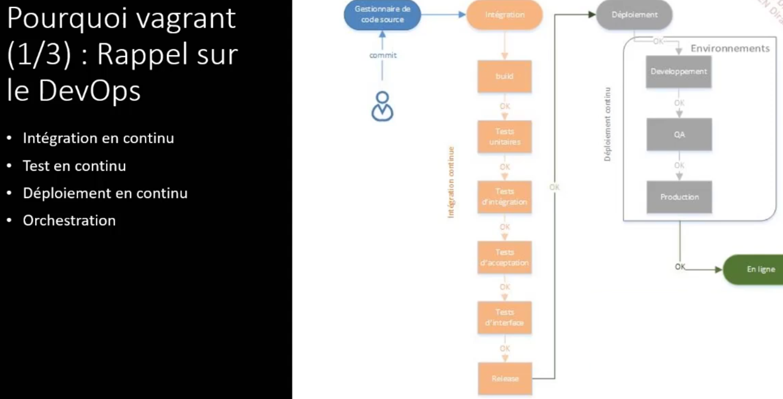

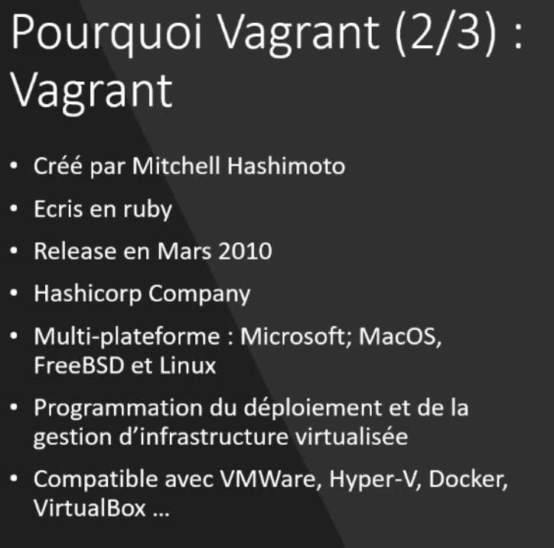

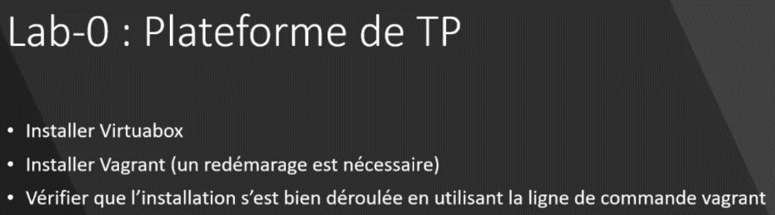

Command list

$ vagrant list-commands --help

**$ vagrant global-status -h**

id name provider state directory

--------------------------------------------------------------------

There are no active Vagrant environments on this computer! Or,

you haven't destroyed and recreated Vagrant environments that were

started with an older version of Vagrant.

**$ vagrant global-status -h**

Usage: vagrant global-status

--prune Prune invalid entries.

--[no-]color Enable or disable color output

--machine-readable Enable machine readable output

-v, --version Display Vagrant version

--debug Enable debug output

--timestamp Enable timestamps on log output

--debug-timestamp Enable debug output with timestamps

--no-tty Enable non-interactive output

-h, --help Print this help

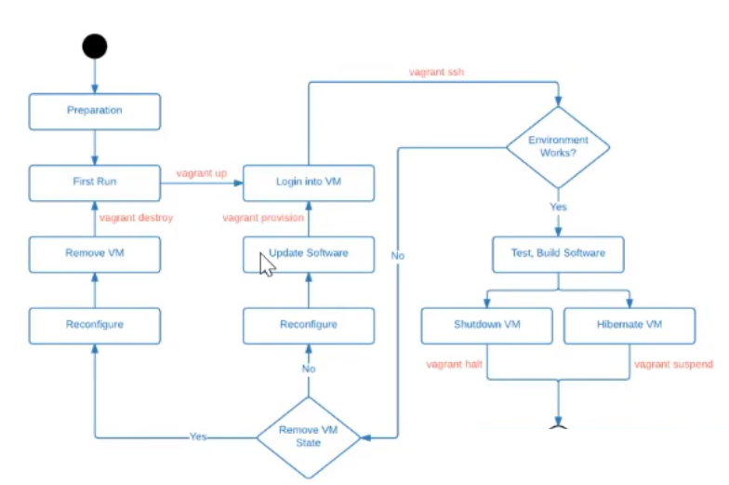

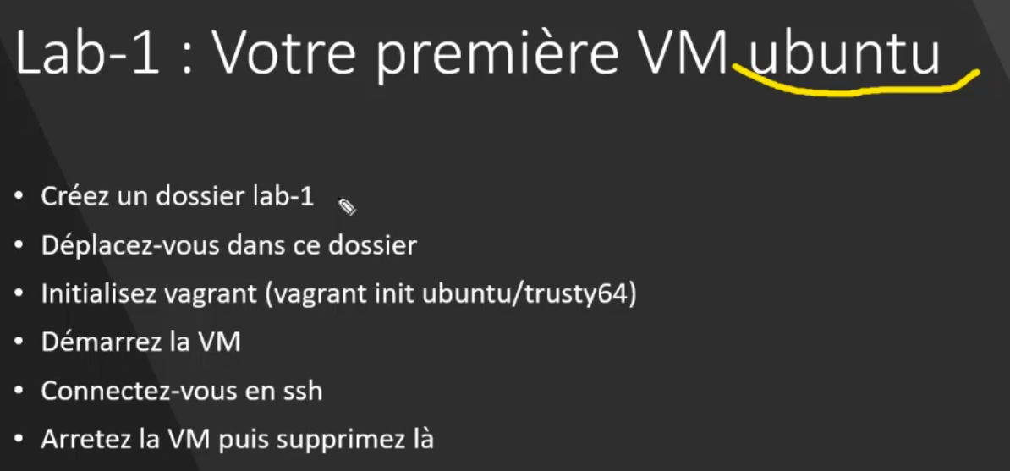

**Lab 1**

Init vagrant file with an ubutu vm

Create a folder lab-1

$ cd lab-1

$ **vagrant init ubuntu/trusty64**

λ vagrant init ubuntu/trusty64

A `Vagrantfile` has been placed in this directory. You are now

ready to `vagrant up` your first virtual environment! Please read

the comments in the Vagrantfile as well as documentation on

`vagrantup.com` for more information on using Vagrant.

Create resource

$ **vagrant up**

==> default: Clearing any previously set network interfaces...

==> default: Preparing network interfaces based on configuration...

default: Adapter 1: nat

==> default: Forwarding ports...

default: 22 (guest) => 2222 (host) (adapter 1)

==> default: Booting VM...

==> default: Waiting for machine to boot. This may take a few minutes...

default: SSH address: 127.0.0.1:2222

default: SSH username: vagrant

default: SSH auth method: private key

default: Warning: Connection aborted. Retrying...

default: Warning: Connection reset. Retrying...

default: Warning: Connection reset. Retrying...

default: Warning: Connection aborted. Retrying...

default: Warning: Connection reset. Retrying...

default: Warning: Connection aborted. Retrying...

default:

default: Vagrant insecure key detected. Vagrant will automatically replace

default: this with a newly generated keypair for better security.

default:

default: Inserting generated public key within guest...

default: Removing insecure key from the guest if it's present...

default: Key inserted! Disconnecting and reconnecting using new SSH key...

==> default: Machine booted and ready!

==> default: Checking for guest additions in VM...

default: The guest additions on this VM do not match the installed version of

default: VirtualBox! In most cases this is fine, but in rare cases it can

default: prevent things such as shared folders from working properly. If you see

default: shared folder errors, please make sure the guest additions within the

default: virtual machine match the version of VirtualBox you have installed on

default: your host and reload your VM.

default:

default: Guest Additions Version: 4.3.40

default: VirtualBox Version: 7.0

==> default: Mounting shared folders...

default: /vagrant => C:/Users/yzaghir/Downloads/vagrant_information/labs/lab-1

Show resources created from the local folder (lab-1)

$ **vagrant status**

default running (virtualbox)

The VM is running. To stop this VM, you can run `vagrant halt` to

shut it down forcefully, or you can run `vagrant suspend` to simply

suspend the virtual machine. In either case, to restart it again,

simply run `vagrant up`.

Show all resources

$ **vagrant global-status**

id name provider state directory

----------------------------------------------------------------------------------------------

**301e**bc2 **default** virtualbox running C:/Users/yzaghir/Downloads/vagrant_information/labs/lab-1

The above shows information about all known Vagrant environments on this machine. This data is cached and may not be completely

up-to-date (use "vagrant global-status --prune" to prune invalid entries). To interact with any of the machines, you can go to that

directory and run Vagrant, or you can use the ID directly with Vagrant commands from any directory. For example:

"vagrant destroy 1a2b3c4d"

Connect to vm with ssh

$ **vagrant ssh**

Welcome to Ubuntu 14.04.6 LTS (GNU/Linux 3.13.0-170-generic x86_64)

* Documentation: https://help.ubuntu.com/

System information disabled due to load higher than 1.0

UA Infrastructure Extended Security Maintenance (ESM) is not enabled.

0 updates can be installed immediately.

0 of these updates are security updates.

Enable UA Infrastructure ESM to receive 64 additional security updates.

See https://ubuntu.com/advantage or run: sudo ua status

New release '16.04.7 LTS' available.

Run 'do-release-upgrade' to upgrade to it.

vagrant@vagrant-ubuntu-trusty-64:~$

Check virtual box

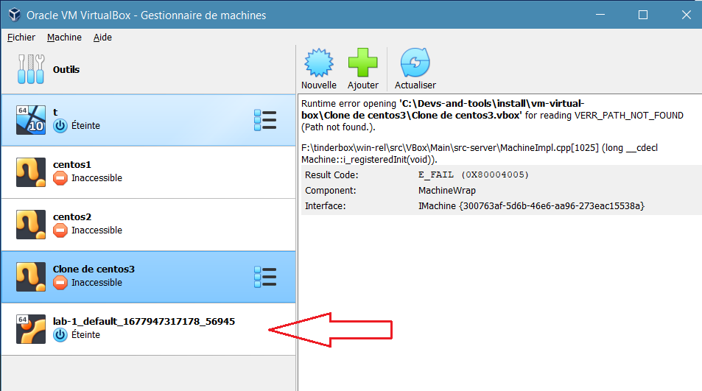

Disconnect from de vm

$ **exist**

Stop vm

**$ vagrant halt**

delete vm

$ **vagrant destroy**

**Vagrant Boxes**

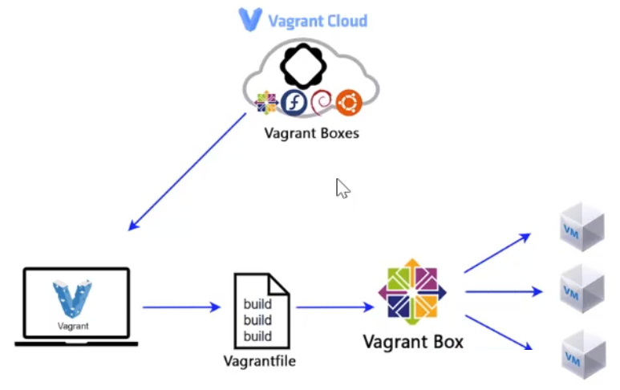

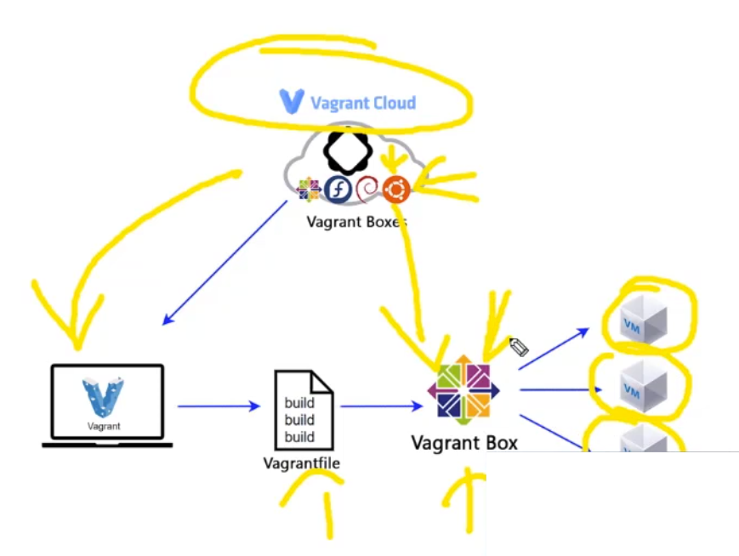

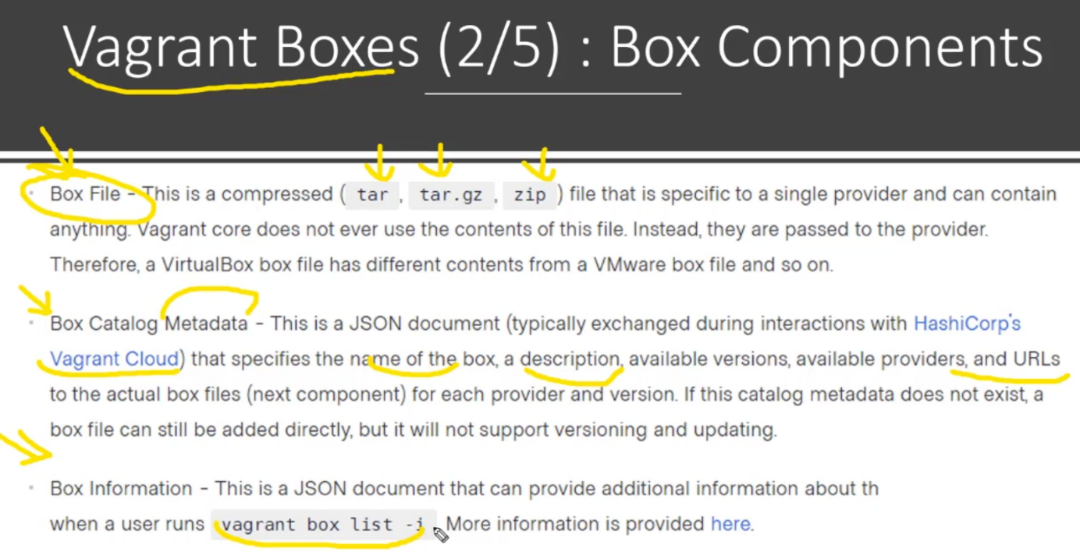

$ **vagrant box list -i**

ubuntu/trusty64 (virtualbox, 20190514.0.0)

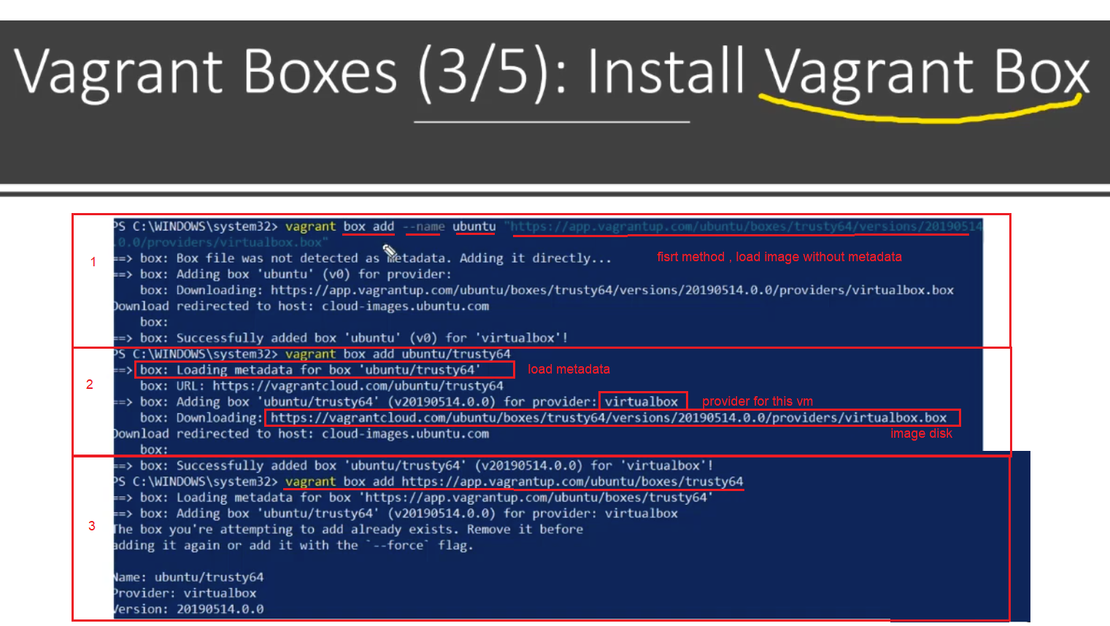

**Version**

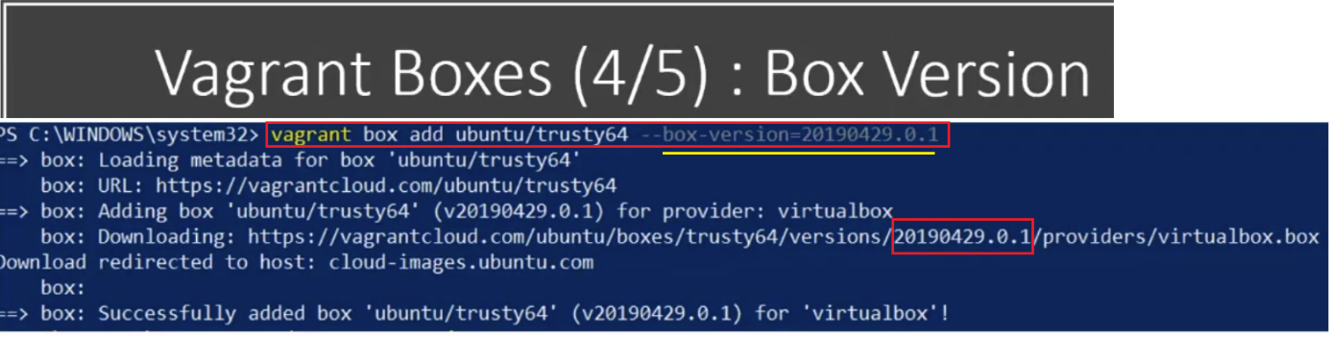

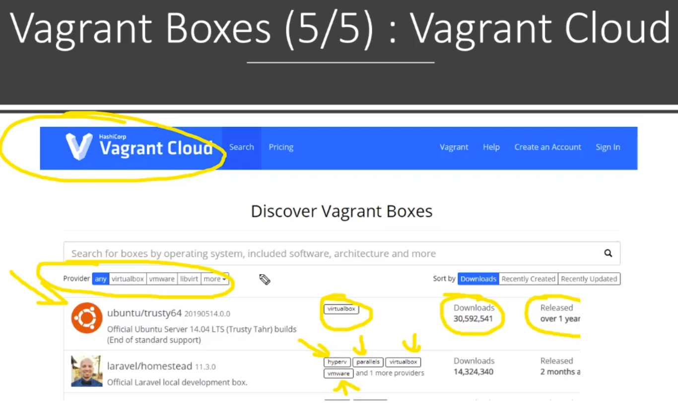

**Create Vbox**

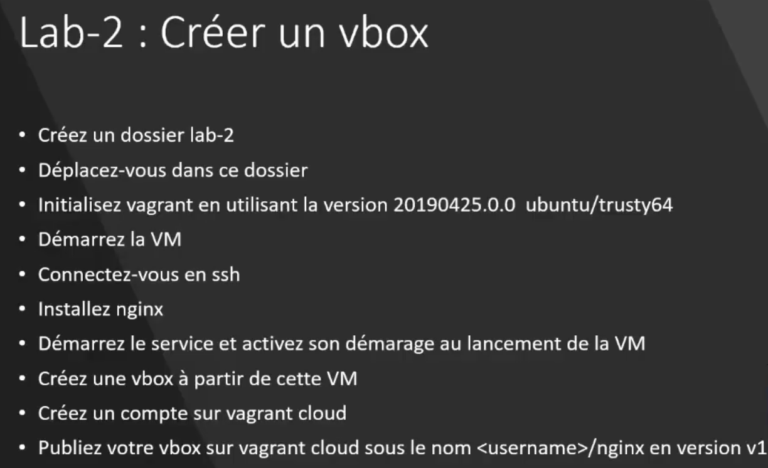

$ **cd ./lab-2**

$ **vagrant init ubuntu/trusty64 -h**

Usage: vagrant init [options] [name [url]]

Options:

--box-version VERSION Version of the box to add

-f, --force Overwrite existing Vagrantfile

-m, --minimal Use minimal Vagrantfile template (no help comments). Ignored with --template

--output FILE Output path for the box. '-' for stdout

--template FILE Path to custom Vagrantfile template

--[no-]color Enable or disable color output

--machine-readable Enable machine readable output

-v, --version Display Vagrant version

--debug Enable debug output

--timestamp Enable timestamps on log output

--debug-timestamp Enable debug output with timestamps

--no-tty Enable non-interactive output

-h, --help Print this help

**$ vagrant init ubuntu/trusty64 --box-version 20190425.0.0**

A `Vagrantfile` has been placed in this directory. You are now

ready to `vagrant up` your first virtual environment! Please read

the comments in the Vagrantfile as well as documentation on

`vagrantup.com` for more information on using Vagrant.

**$ sudo apt-get update**

λ vagrant up

Bringing machine 'default' up with 'virtualbox' provider...

==> default: Box 'ubuntu/trusty64' could not be found. Attempting to find and install...

default: Box Provider: virtualbox

default: Box Version: 20190425.0.0

==> default: Loading metadata for box 'ubuntu/trusty64'

default: URL: https://vagrantcloud.com/ubuntu/trusty64

==> default: Adding box 'ubuntu/trusty64' (v20190425.0.0) for provider: virtualbox

default: Downloading: https://vagrantcloud.com/ubuntu/boxes/trusty64/versions/20190425.0.0/providers/virtualbox.box

Download redirected to host: cloud-images.ubuntu.com

default:

==> default: Successfully added box 'ubuntu/trusty64' (v20190425.0.0) for 'virtualbox'!

==> default: Importing base box 'ubuntu/trusty64'...

==> default: Matching MAC address for NAT networking...

==> default: Checking if box 'ubuntu/trusty64' version '20190425.0.0' is up to date...

==> default: Setting the name of the VM: lab-2_default_1678026923959_99670

==> default: Clearing any previously set forwarded ports...

==> default: Clearing any previously set network interfaces...

==> default: Preparing network interfaces based on configuration...

default: Adapter 1: nat

==> default: Forwarding ports...

default: 22 (guest) => 2222 (host) (adapter 1)

==> default: Booting VM...

==> default: Waiting for machine to boot. This may take a few minutes...

default: SSH address: 127.0.0.1:2222

default: SSH username: vagrant

default: SSH auth method: private key

default: Warning: Connection reset. Retrying...

default: Warning: Connection aborted. Retrying...

default: Warning: Connection reset. Retrying...

default:

default: Vagrant insecure key detected. Vagrant will automatically replace

default: this with a newly generated keypair for better security.

default:

default: Inserting generated public key within guest...

default: Removing insecure key from the guest if it's present...

default: Key inserted! Disconnecting and reconnecting using new SSH key...

==> default: Machine booted and ready!

==> default: Checking for guest additions in VM...

default: The guest additions on this VM do not match the installed version of

default: VirtualBox! In most cases this is fine, but in rare cases it can

default: prevent things such as shared folders from working properly. If you see

default: shared folder errors, please make sure the guest additions within the

default: virtual machine match the version of VirtualBox you have installed on

default: your host and reload your VM.

default:

default: Guest Additions Version: 4.3.40

default: VirtualBox Version: 7.0

==> default: Mounting shared folders...

default: /vagrant => C:/Users/yzaghir/Downloads/vagrant_information/labs/lab-2

**$ vagrant up**

Bringing machine 'default' up with 'virtualbox' provider...

==> default: Checking if box 'ubuntu/trusty64' version '20190425.0.0' is up to date...

==> default: Machine already provisioned. Run `vagrant provision` or use the `--provision`

==> default: flag to force provisioning. Provisioners marked to run always will still run.

**$ vagrant ssh**

$ sudo apt-get update

**$ sudo apt-get install nginx -y**

**$ vagrant@vagrant-ubuntu-trusty-64:~$ sudo service nginx start**

**$ sudo service nginx status**

* nginx is running

**$ curl 127.0.0.1**

**$exit**

Log to vagrant cloud

Create a image

In local machine

$ **vagrant package --output nginx.box**

==> default: Attempting graceful shutdown of VM...

==> default: Clearing any previously set forwarded ports...

==> default: Exporting VM...

==> default: Compressing package to: C:/Users/yzaghir/Downloads/vagrant_information/labs/lab-2/nginx.box

After eatch test you destroy a VM created

**$ ./lab-2**

**$ vagrant destroy -f**

λ vagrant destroy -f

==> default: Destroying VM and associated drives...

$ **ls -l**

total 463428

-rw-r--r-- 1 yzaghir 1049089 474543040 mars 5 16:57 nginx.box

-rw-r--r-- 1 yzaghir 1049089 3133 mars 5 15:30 Vagrantfile

**$ rm .\nginx.box**

**$ ls -al**

total 4

drwxr-xr-x 1 yzaghir 1049089 0 mars 5 17:04 ./

drwxr-xr-x 1 yzaghir 1049089 0 mars 5 15:04 ../

drwxr-xr-x 1 yzaghir 1049089 0 mars 5 15:32 .vagrant/

-rw-r--r-- 1 yzaghir 1049089 3133 mars 5 15:30 Vagrantfile

<https://app.vagrantup.com/boxes/search>

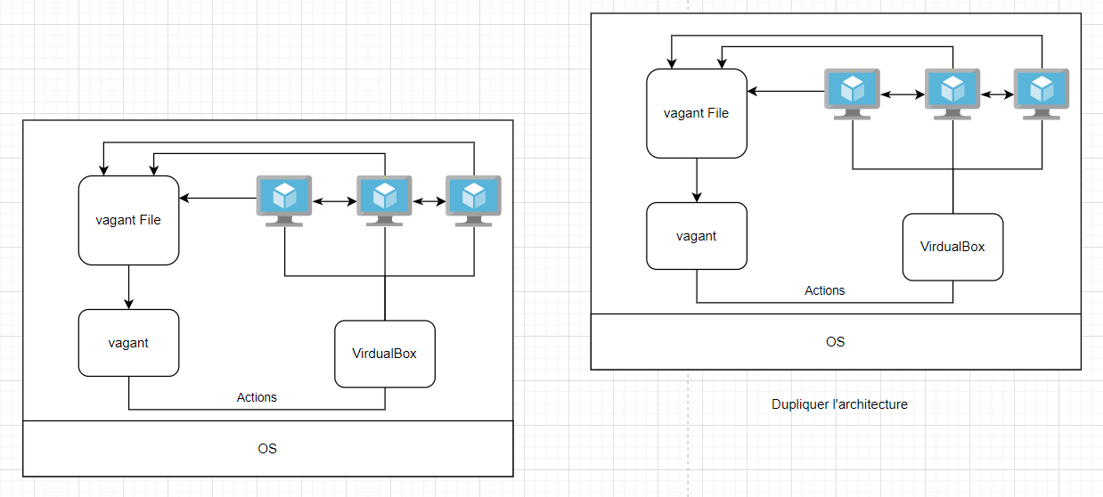**Vagrant File**

**Create vagrant file**

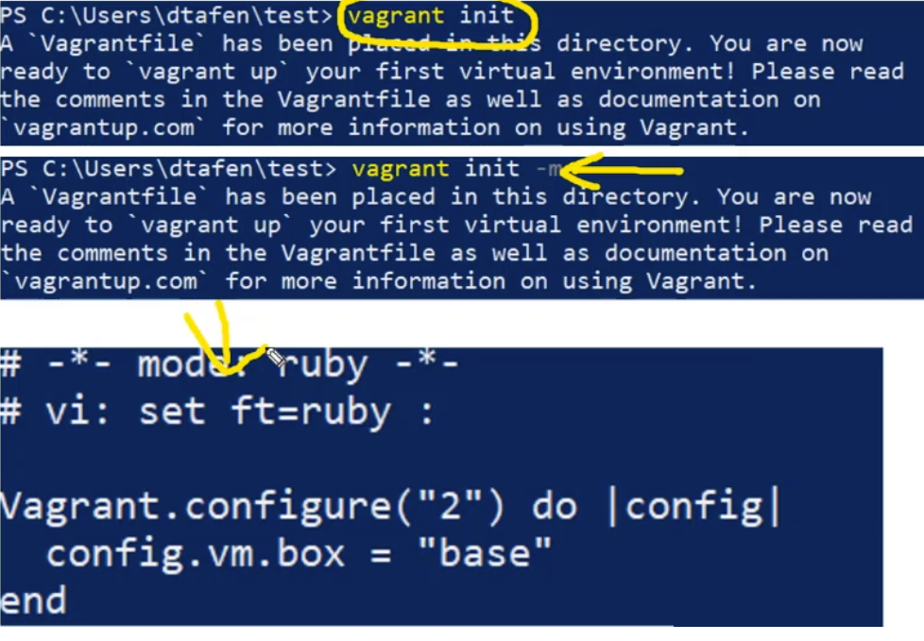

Vagrant file va être constituer sous format d’arbre

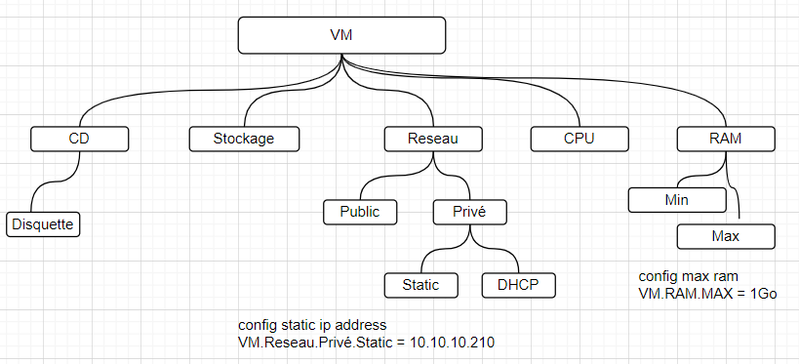

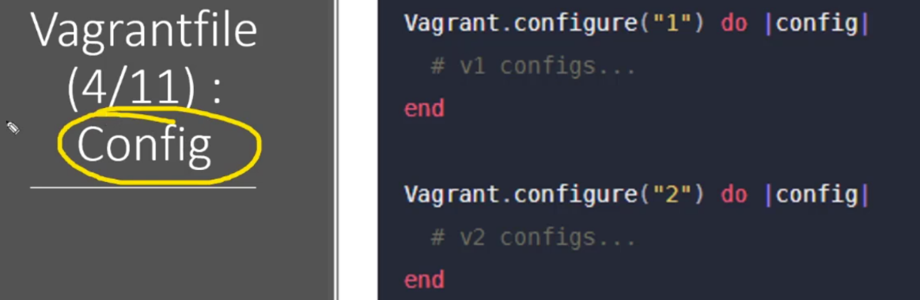

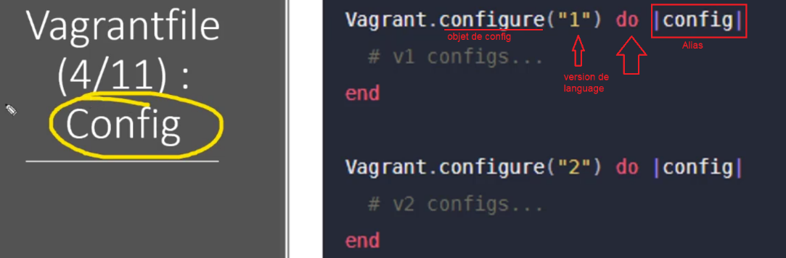

<https://developer.hashicorp.com/vagrant/docs/vagrantfile/version>

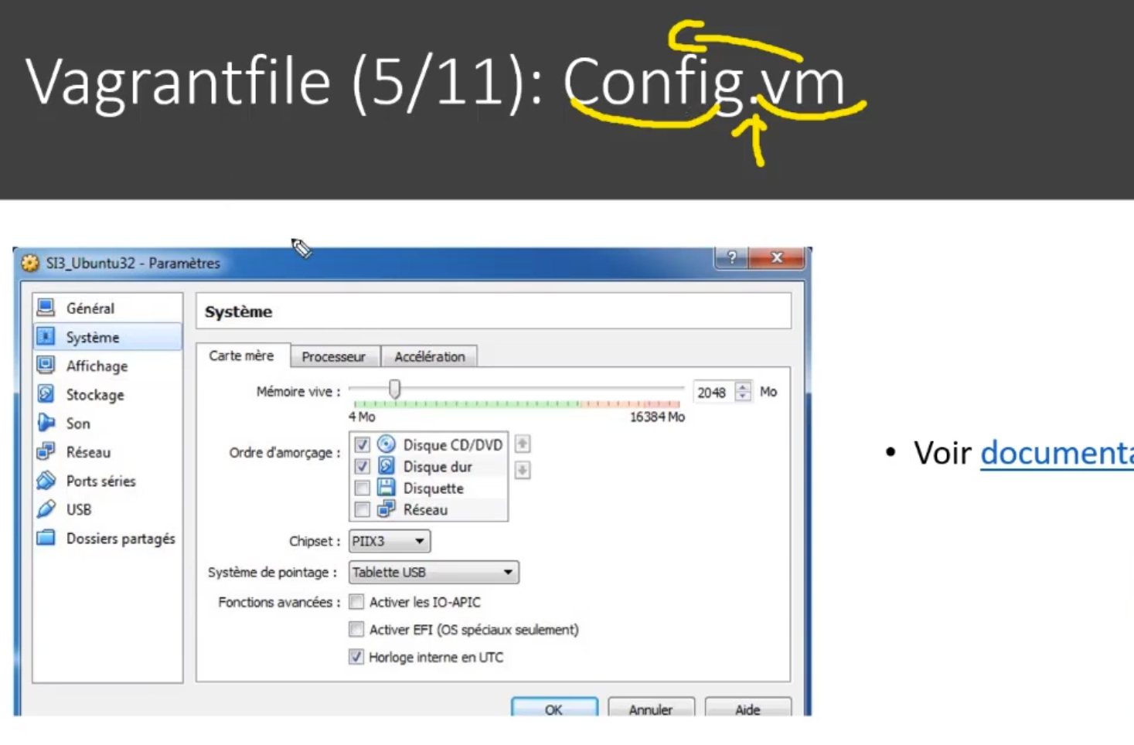

<https://developer.hashicorp.com/vagrant/docs/vagrantfile/machine_settings>

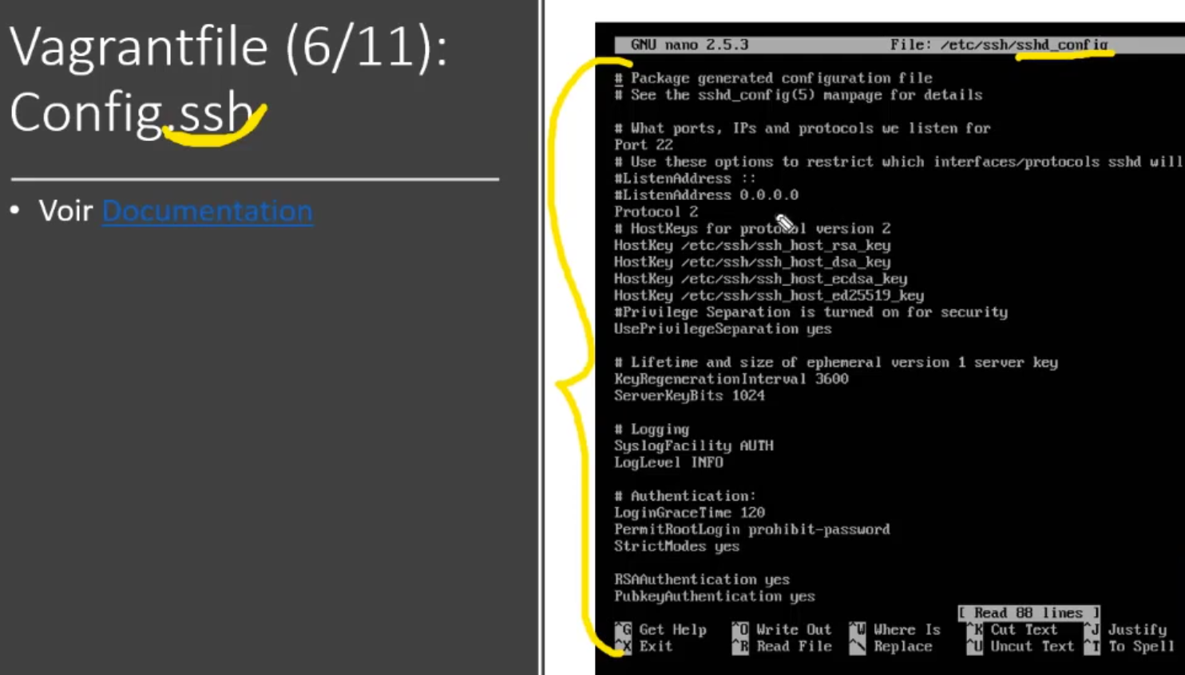

<https://developer.hashicorp.com/vagrant/docs/vagrantfile/ssh_settings>

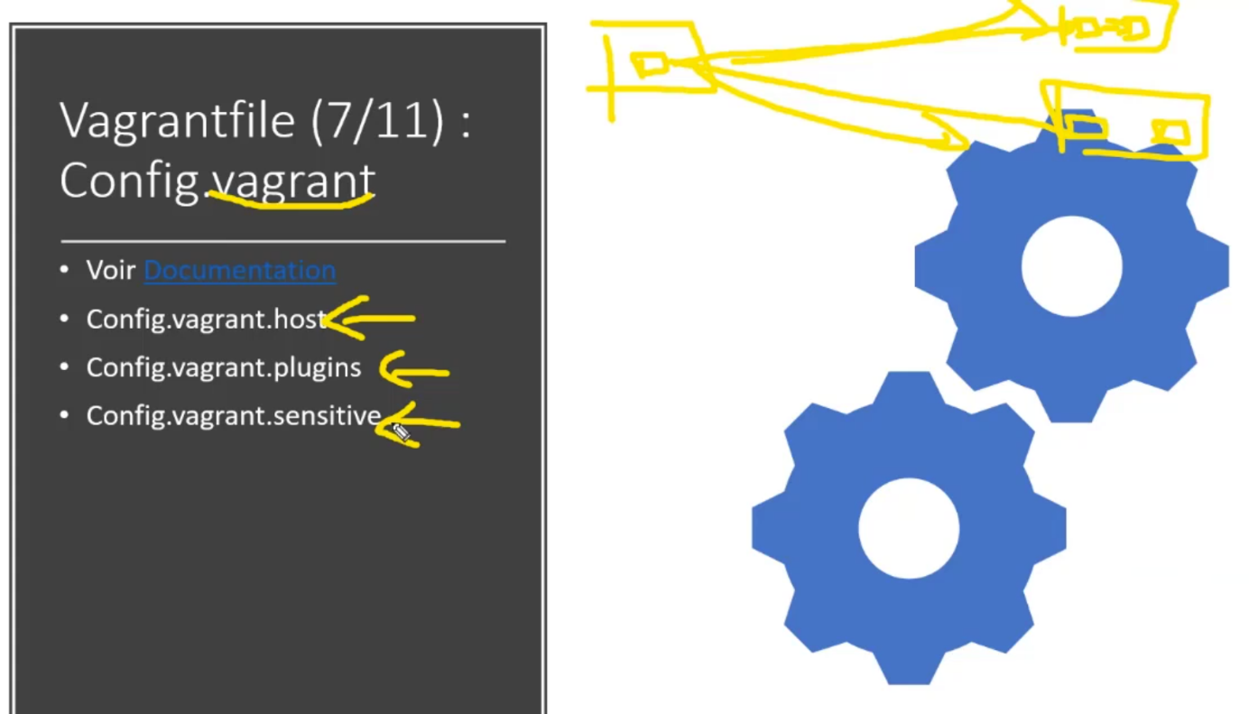

<https://developer.hashicorp.com/vagrant/docs/vagrantfile/vagrant_settings>

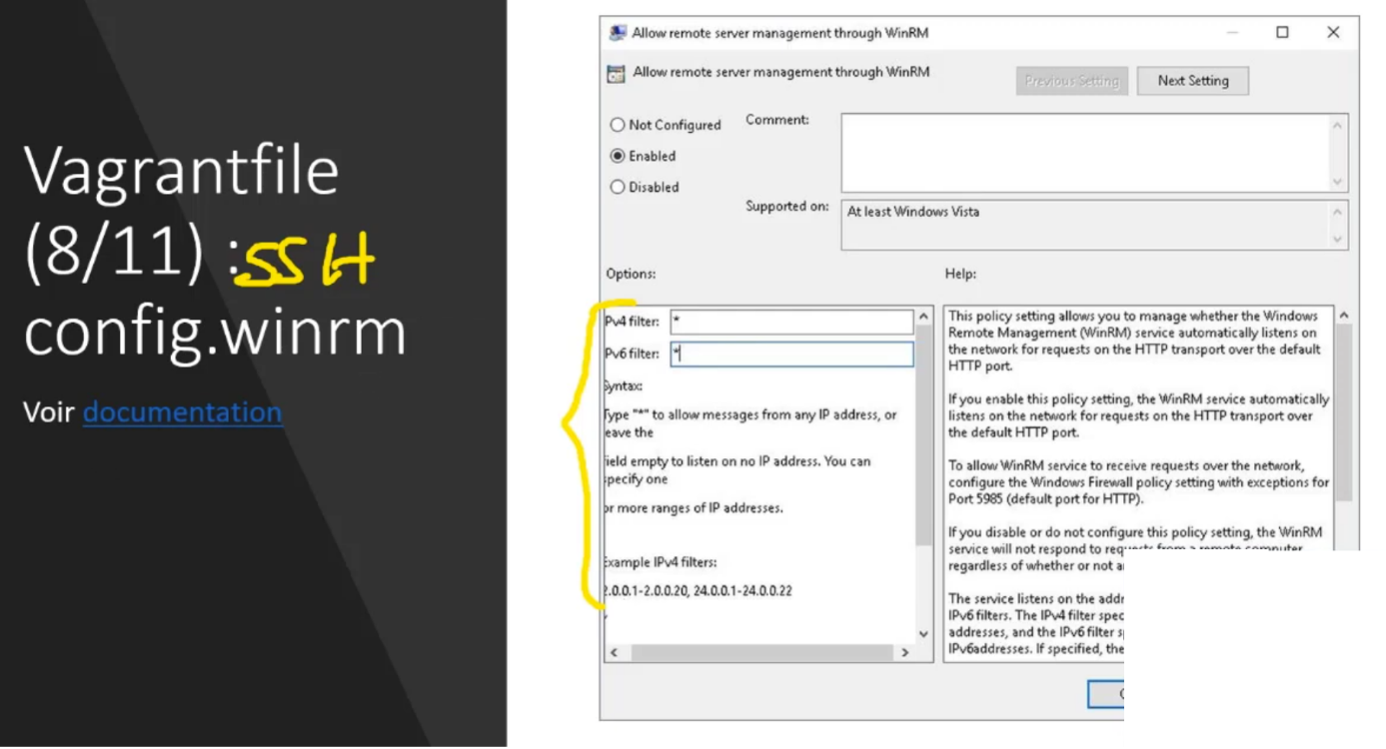

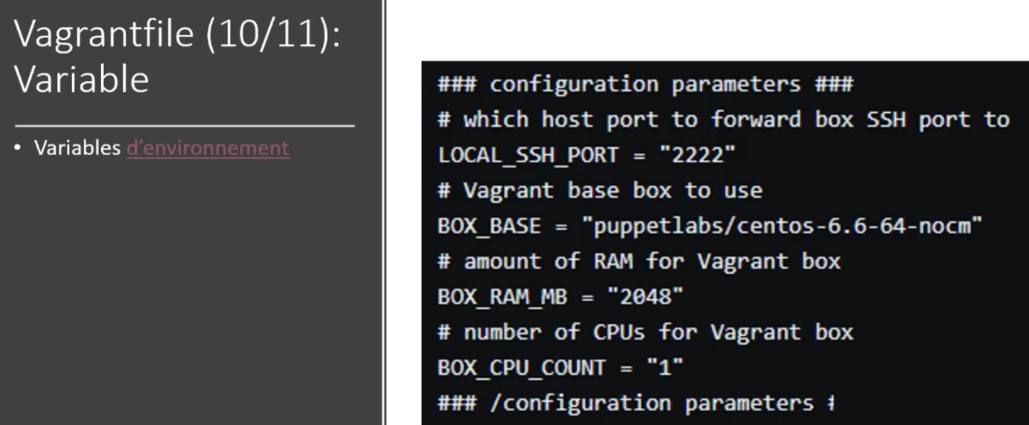

<https://developer.hashicorp.com/vagrant/docs/other/environmental-variables>

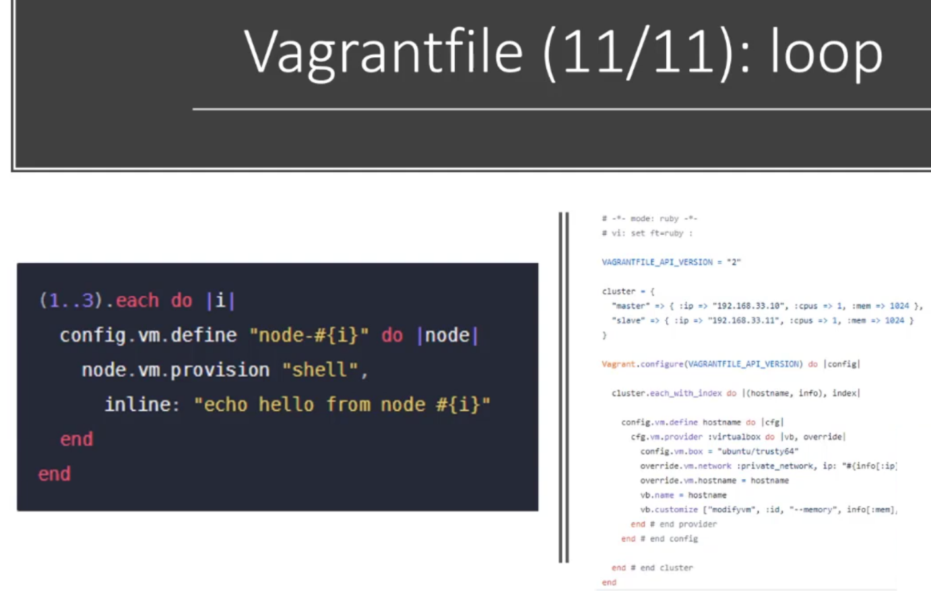

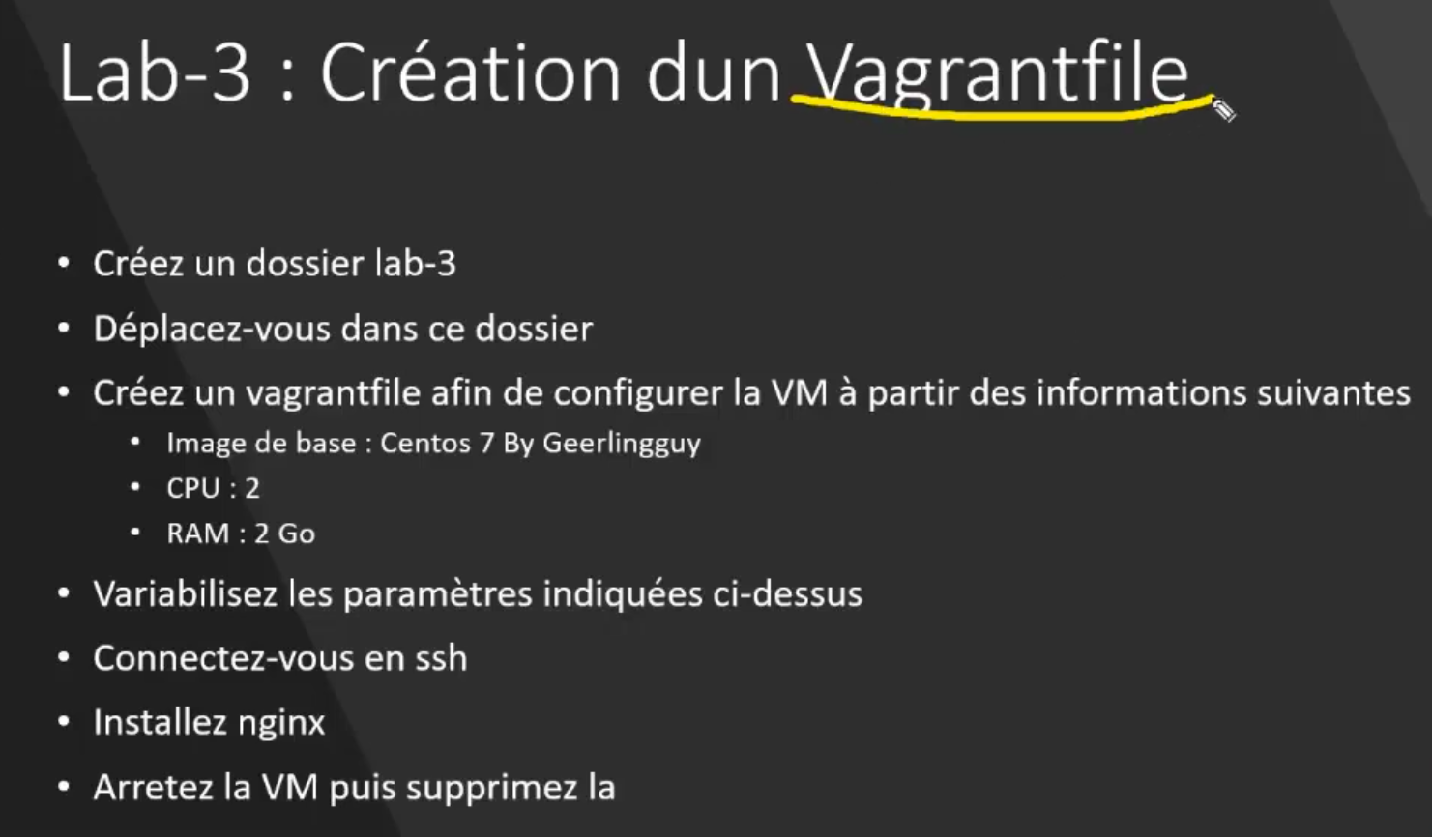

<https://app.vagrantup.com/boxes/search?utf8=%E2%9C%93&sort=downloads&provider=virtualbox&q=centos7>

**$ mkdir lab-3**

**$ cd lab-3**

**$ vagrant init geerlingguy/centos7**

A `Vagrantfile` has been placed in this directory. You are now

ready to `vagrant up` your first virtual environment! Please read

the comments in the Vagrantfile as well as documentation on

`vagrantup.com` for more information on using Vagrant.

C:\Users\yzaghir\Downloads\vagrant_information\labs\lab-3 (master -> origin)

$ rm Vagrantfile

-m = version minimal

$ vagrant init geerlingguy/centos7 -m

A `Vagrantfile` has been placed in this directory. You are now

ready to `vagrant up` your first virtual environment! Please read

the comments in the Vagrantfile as well as documentation on

`vagrantup.com` for more information on using Vagrant.

Vagrantfile

# -*- mode: ruby -*-

# vi: set ft=ruby :

RAM = 2048

CPU = 2

Vagrant.configure("2") do |config|

  config.vm.box = "geerlingguy/centos7"

  # https://developer.hashicorp.com/vagrant/docs/providers/virtualbox/configuration

  # 2 cpu and 2048 of ram

  config.vm.provider "virtualbox" do |v|

    v.memory = RAM

    v.cpus = CPU

  end

end

validate Vagrantfile

$ **vagrant validate**

Vagrantfile validated successfully.

Create vm

$ **vagrant up**

Bringing machine 'default' up with 'virtualbox' provider...

==> default: Box 'geerlingguy/centos7' could not be found. Attempting to find and install...

default: Box Provider: virtualbox

default: Box Version: >= 0

==> default: Loading metadata for box 'geerlingguy/centos7'

default: URL: https://vagrantcloud.com/geerlingguy/centos7

==> default: Adding box 'geerlingguy/centos7' (v1.2.27) for provider: virtualbox

default: Downloading: https://vagrantcloud.com/geerlingguy/boxes/centos7/versions/1.2.27/providers/virtualbox.box

default:

==> default: Successfully added box 'geerlingguy/centos7' (v1.2.27) for 'virtualbox'!

==> default: Importing base box 'geerlingguy/centos7'...

==> default: Matching MAC address for NAT networking...

==> default: Checking if box 'geerlingguy/centos7' version '1.2.27' is up to date...

==> default: Setting the name of the VM: lab-3_default_1678054959398_24878

==> default: Clearing any previously set network interfaces...

==> default: Preparing network interfaces based on configuration...

default: Adapter 1: nat

==> default: Forwarding ports...

default: 22 (guest) => 2222 (host) (adapter 1)

==> default: Running 'pre-boot' VM customizations...

==> default: Booting VM...

==> default: Waiting for machine to boot. This may take a few minutes...

default: SSH address: 127.0.0.1:2222

default: SSH username: vagrant

default: SSH auth method: private key

default:

default: Vagrant insecure key detected. Vagrant will automatically replace

default: this with a newly generated keypair for better security.

default:

default: Inserting generated public key within guest...

default: Removing insecure key from the guest if it's present...

default: Key inserted! Disconnecting and reconnecting using new SSH key...

==> default: Machine booted and ready!

==> default: Checking for guest additions in VM...

default: The guest additions on this VM do not match the installed version of

default: VirtualBox! In most cases this is fine, but in rare cases it can

default: prevent things such as shared folders from working properly. If you see

default: shared folder errors, please make sure the guest additions within the

default: virtual machine match the version of VirtualBox you have installed on

default: your host and reload your VM.

default:

default: Guest Additions Version: 6.1.32

default: VirtualBox Version: 7.0

==> default: Mounting shared folders...

default: /vagrant => C:/Users/yzaghir/Downloads/vagrant_information/labs/lab-3

**$ vagrant ssh**

**$ sudo yum install nginx**

**$ sudo systemctl status nginx**

● nginx.service - The nginx HTTP and reverse proxy server

Loaded: loaded (/usr/lib/systemd/system/nginx.service; disabled; vendor preset: disabled)

Active: inactive (dead)

**$ sudo systemctl start nginx**

**$ curl 127.0.0.1**

**$ exit**

**$ vagrant destroy -f**

**$ vagrant global-status**

id name provider state directory

-----------------------------------------------------------------------------------------------

**Networking**

**Port-forwarding**

<https://developer.hashicorp.com/vagrant/docs/networking/forwarded_ports>

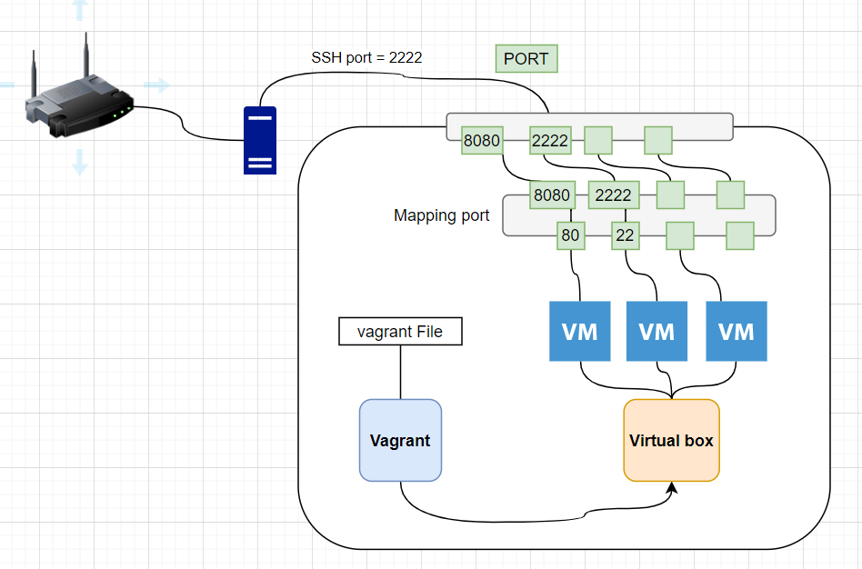

**Private network**

<https://developer.hashicorp.com/vagrant/docs/networking/private_network>

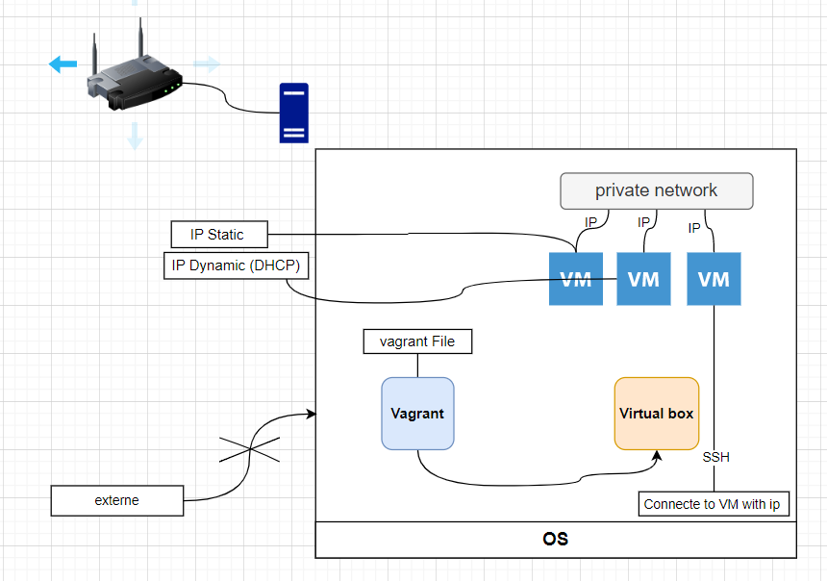

**Public network**

https://developer.hashicorp.com/vagrant/docs/networking/public_network

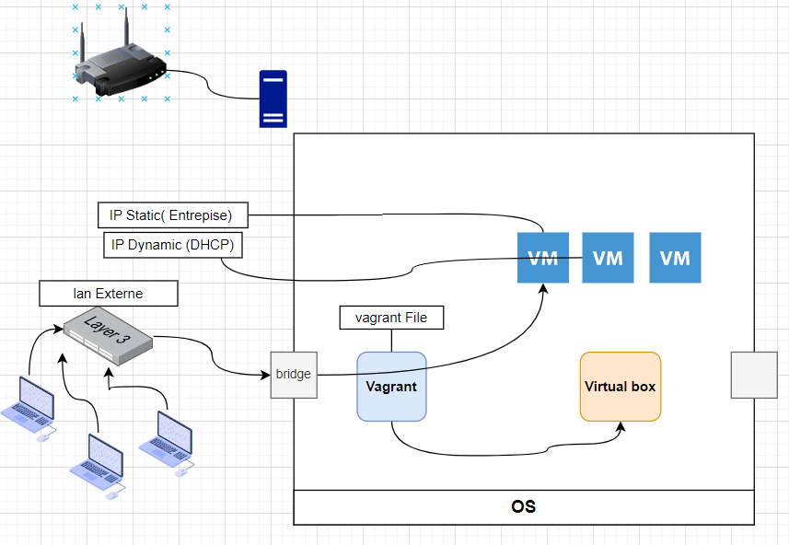

**Lab-4 Private network**

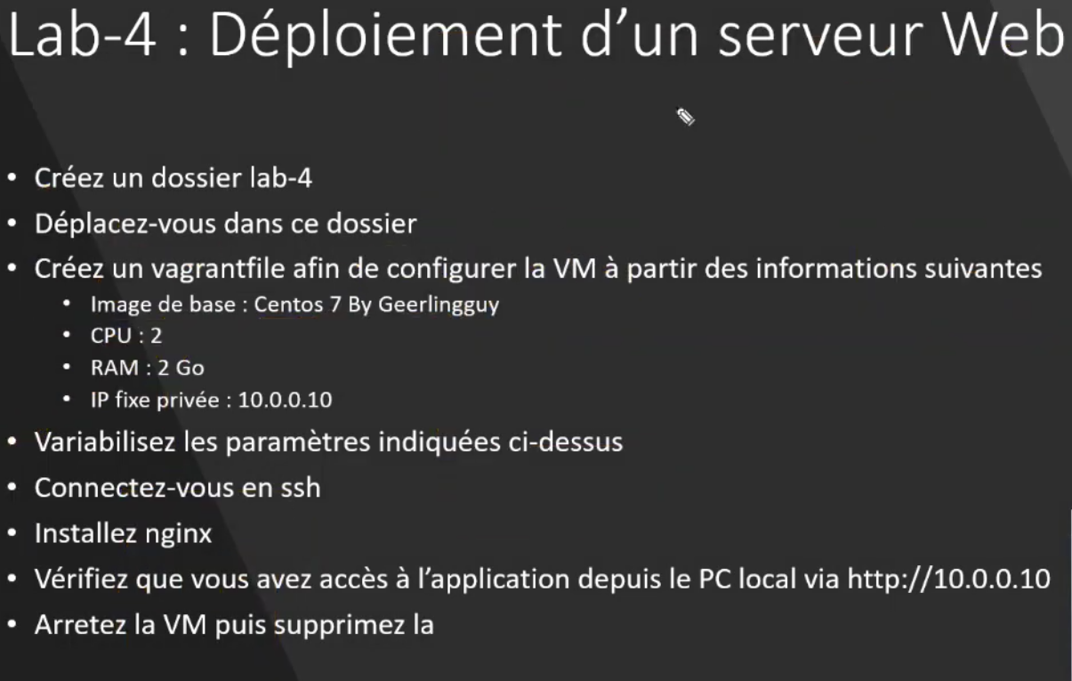

$ **mkdir lab-4**

$ **cd lab-4**

$ **vagrant init geerlingguy/centos7 -m**

Edit Vgranfile

# -*- mode: ruby -*-

# vi: set ft=ruby :

RAM = 2048

CPU = 2

IP = "10.0.0.10"

Vagrant.configure("2") do |config|

  config.vm.box = "geerlingguy/centos7"

  config.vm.network "private_network", ip: IP

  # https://developer.hashicorp.com/vagrant/docs/providers/virtualbox/configuration

  # 2 cpu and 2048 of ram

  config.vm.provider "virtualbox" do |v|

    v.memory = RAM

    v.cpus = CPU

  end

end

$ **vagrant validate**

Vagrantfile validated successfully

$ **vagrant up**

Bringing machine 'default' up with 'virtualbox' provider...

==> default: Importing base box 'geerlingguy/centos7'...

==> default: Matching MAC address for NAT networking...

==> default: Checking if box 'geerlingguy/centos7' version '1.2.27' is up to date...

==> default: Setting the name of the VM: lab-4_default_1678207053451_86114

==> default: Clearing any previously set network interfaces...

==> default: Preparing network interfaces based on configuration...

default: Adapter 1: nat

default: Adapter 2: hostonly

==> default: Forwarding ports...

default: 22 (guest) => 2222 (host) (adapter 1)

==> default: Running 'pre-boot' VM customizations...

==> default: Booting VM...

==> default: Waiting for machine to boot. This may take a few minutes...

default: SSH address: 127.0.0.1:2222

default: SSH username: vagrant

default: SSH auth method: private key

default: Warning: Connection reset. Retrying...

default: Warning: Connection aborted. Retrying...

default: Warning: Connection reset. Retrying...

default: Warning: Connection aborted. Retrying...

default: Warning: Connection reset. Retrying...

default: Warning: Connection aborted. Retrying...

default:

default: Vagrant insecure key detected. Vagrant will automatically replace

default: this with a newly generated keypair for better security.

default:

default: Inserting generated public key within guest...

default: Removing insecure key from the guest if it's present...

default: Key inserted! Disconnecting and reconnecting using new SSH key...

==> default: Machine booted and ready!

==> default: Checking for guest additions in VM...

default: The guest additions on this VM do not match the installed version of

default: VirtualBox! In most cases this is fine, but in rare cases it can

default: prevent things such as shared folders from working properly. If you see

default: shared folder errors, please make sure the guest additions within the

default: virtual machine match the version of VirtualBox you have installed on

default: your host and reload your VM.

default:

default: Guest Additions Version: 6.1.32

default: VirtualBox Version: 7.0

==> default: Configuring and enabling network interfaces...

==> default: Mounting shared folders...

default: /vagrant => C:/Users/yzaghir/Downloads/vagrant_information/labs/lab-4

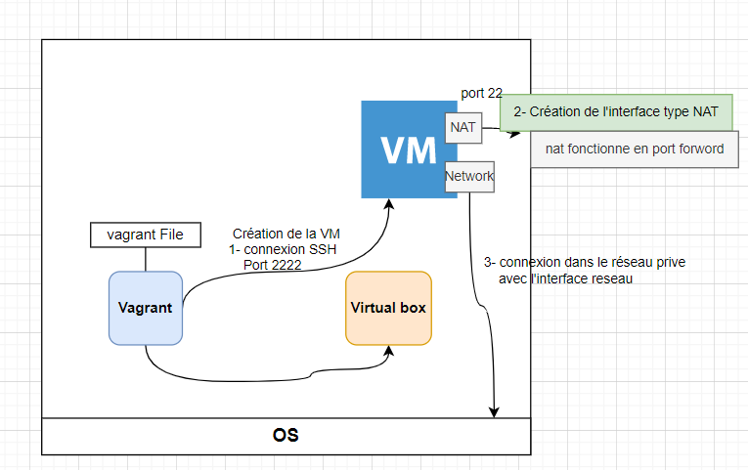

$ **ssh vagrant@10.0.0.10**

The authenticity of host '10.0.0.10 (10.0.0.10)' can't be established.

ECDSA key fingerprint is SHA256:mc0p/z9/+4s4SjrnLCx/tV2t8ziWNB049IHGz1V0a8U.

Are you sure you want to continue connecting (yes/no/[fingerprint])? yes

Warning: Permanently added '10.0.0.10' (ECDSA) to the list of known hosts.

vagrant@10.0.0.10's password:vagrant

[vagrant@localhost ~]$

**$ sudo yum install nginx**

**Pas besoin de faire $ssh -p 2222**

**On a un accès direct à la vm**

$ **sudo systemctl start nginx**

Test in browser with

<http://10.0.0.10/>

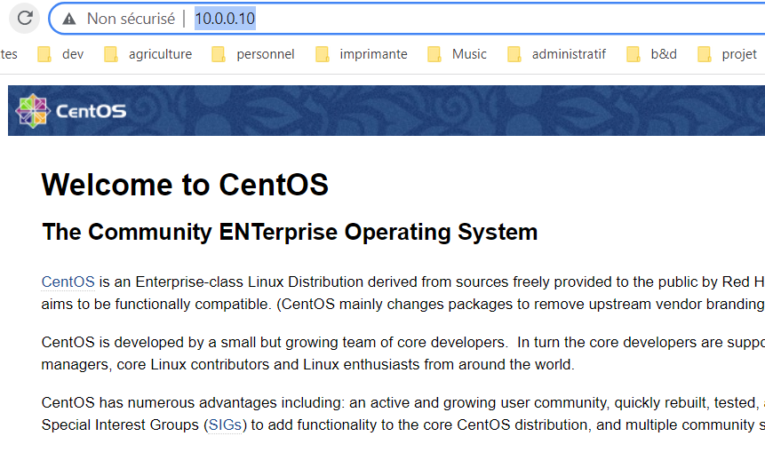

$ **exit**

$ **vagrant destroy -f**

==> default: Forcing shutdown of VM...

==> default: Destroying VM and associated drives...

**Multi machine**

Pourquoi ?

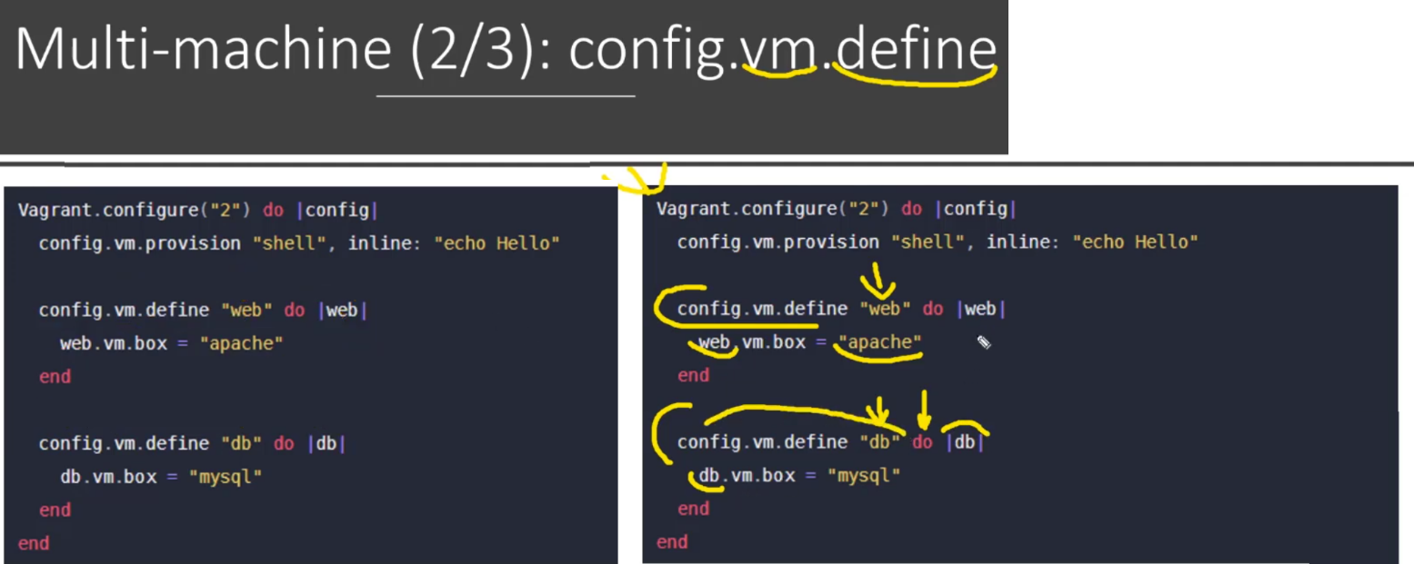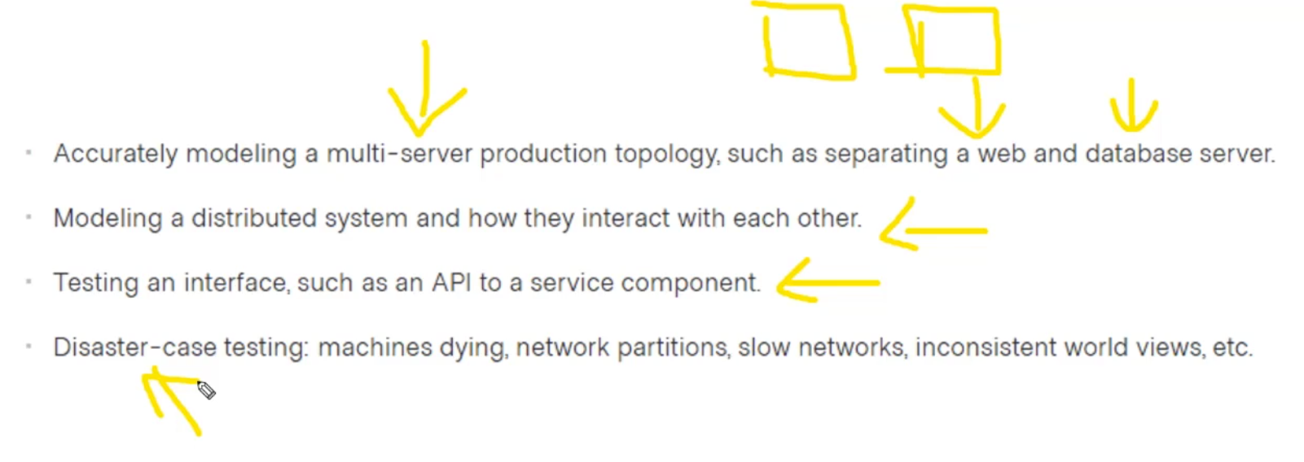



<https://developer.hashicorp.com/vagrant/docs/multi-machine>

**Lab-5**

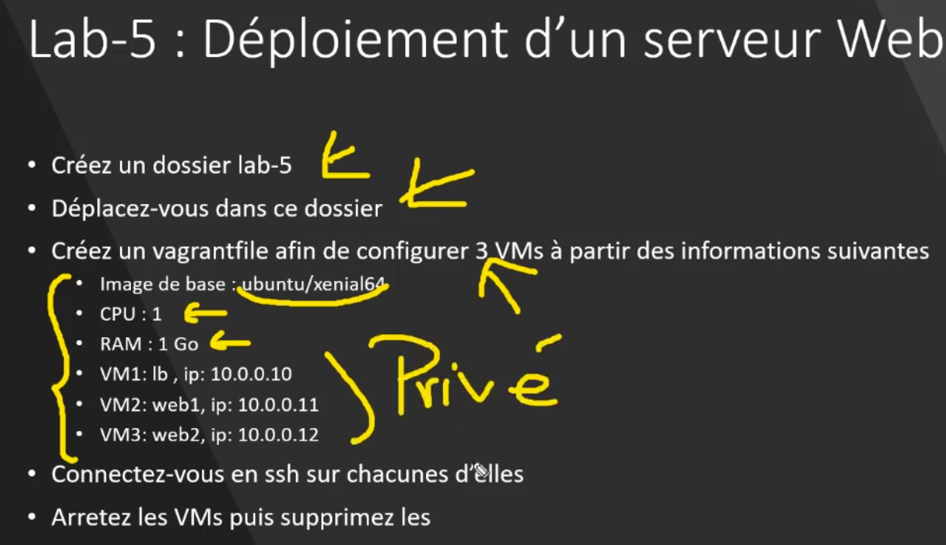

$ mkdir lab-5

$ cd lab-5

$ vagrant init -m

Edit Vagantfile

RAM = 1024

CPU = 1

Vagrant.configure("2") do |config|

  # Configure load balancer machine

  config.vm.define "lb" do |lb|

    lb.vm.box = "ubuntu/xenial64"

    lb.vm.network "private_network" , ip: "10.0.0.10"

  end

  config.vm.provider "virtualbox" do |v|

    v.memory = RAM

    v.cpus = CPU

  end

  # Configure first web machine

  config.vm.define "web1" do |web1|

    web1.vm.box = "ubuntu/xenial64"

    web1.vm.network "private_network" , ip: "10.0.0.11"

  end

  config.vm.provider "virtualbox" do |v|

    v.memory = RAM

    v.cpus = CPU

  end

  # Configure first web machine

  config.vm.define "web2" do |web2|

    web2.vm.box = "ubuntu/xenial64"

    web2.vm.network "private_network" , ip: "10.0.0.12"

  end

  config.vm.provider "virtualbox" do |v|

    v.memory = RAM

    v.cpus = CPU

  end

end

$ **vagrant validate**

Vagrantfile validated successfully.

$ **vagrant up**

Bringing machine 'lb' up with 'virtualbox' provider...

Bringing machine 'web1' up with 'virtualbox' provider...

==> lb: Importing base box 'ubuntu/xenial64'...

==> lb: Matching MAC address for NAT networking...

==> lb: Checking if box 'ubuntu/xenial64' version '20211001.0.0' is up to date...

==> lb: Setting the name of the VM: lab-5_lb_1678214114821_46783

==> lb: Clearing any previously set network interfaces...

==> lb: Preparing network interfaces based on configuration...

lb: Adapter 1: nat

lb: Adapter 2: hostonly

==> lb: Forwarding ports...

lb: 22 (guest) => 2222 (host) (adapter 1)

==> lb: Running 'pre-boot' VM customizations...

==> lb: Booting VM...

==> lb: Waiting for machine to boot. This may take a few minutes...

lb: SSH address: 127.0.0.1:2222

lb: SSH username: vagrant

lb: SSH auth method: private key

lb: Warning: Connection reset. Retrying...

lb: Warning: Connection aborted. Retrying...

lb:

lb: Vagrant insecure key detected. Vagrant will automatically replace

lb: this with a newly generated keypair for better security.

lb:

lb: Inserting generated public key within guest...

lb: Removing insecure key from the guest if it's present...

lb: Key inserted! Disconnecting and reconnecting using new SSH key...

==> lb: Machine booted and ready!

==> lb: Checking for guest additions in VM...

lb: The guest additions on this VM do not match the installed version of

lb: VirtualBox! In most cases this is fine, but in rare cases it can

lb: prevent things such as shared folders from working properly. If you see

lb: shared folder errors, please make sure the guest additions within the

lb: virtual machine match the version of VirtualBox you have installed on

lb: your host and reload your VM.

lb:

lb: Guest Additions Version: 5.1.38

lb: VirtualBox Version: 7.0

==> lb: Configuring and enabling network interfaces...

==> lb: Mounting shared folders...

lb: /vagrant => C:/Users/yzaghir/Downloads/vagrant_information/labs/lab-5

==> web1: Importing base box 'ubuntu/xenial64'...

==> web1: Matching MAC address for NAT networking...

==> web1: Checking if box 'ubuntu/xenial64' version '20211001.0.0' is up to date...

==> web1: Setting the name of the VM: lab-5_web1_1678214241419_45670

==> web1: Fixed port collision for 22 => 2222. Now on port 2200.

==> web1: Clearing any previously set network interfaces...

==> web1: Preparing network interfaces based on configuration...

web1: Adapter 1: nat

web1: Adapter 2: hostonly

web1: Adapter 3: hostonly

==> web1: Forwarding ports...

web1: 22 (guest) => 2200 (host) (adapter 1)

==> web1: Running 'pre-boot' VM customizations...

==> web1: Booting VM...

==> web1: Waiting for machine to boot. This may take a few minutes...

web1: SSH address: 127.0.0.1:2200

web1: SSH username: vagrant

web1: SSH auth method: private key

web1:

web1: Vagrant insecure key detected. Vagrant will automatically replace

web1: this with a newly generated keypair for better security.

web1:

web1: Inserting generated public key within guest...

web1: Removing insecure key from the guest if it's present...

web1: Key inserted! Disconnecting and reconnecting using new SSH key...

==> web1: Machine booted and ready!

==> web1: Checking for guest additions in VM...

web1: The guest additions on this VM do not match the installed version of

web1: VirtualBox! In most cases this is fine, but in rare cases it can

web1: prevent things such as shared folders from working properly. If you see

web1: shared folder errors, please make sure the guest additions within the

web1: virtual machine match the version of VirtualBox you have installed on

web1: your host and reload your VM.

web1:

web1: Guest Additions Version: 5.1.38

web1: VirtualBox Version: 7.0

==> web1: Configuring and enabling network interfaces...

==> web1: Mounting shared folders...

web1: /vagrant => C:/Users/yzaghir/Downloads/vagrant_information/labs/lab-5

$ **vagrant status**

Current machine states:

lb running (virtualbox)

web1 running (virtualbox)

web2 running (virtualbox)

This environment represents multiple VMs. The VMs are all listed

above with their current state. For more information about a specific

VM, run `vagrant status NAME`.

$ **vagrant ssh lb**

**$ ip a**

1: lo: <LOOPBACK,UP,LOWER_UP> mtu 65536 qdisc noqueue state UNKNOWN group default qlen 1

link/loopback 00:00:00:00:00:00 brd 00:00:00:00:00:00

inet 127.0.0.1/8 scope host lo

valid_lft forever preferred_lft forever

inet6 ::1/128 scope host

valid_lft forever preferred_lft forever

2: enp0s3: <BROADCAST,MULTICAST,UP,LOWER_UP> mtu 1500 qdisc pfifo_fast state UP group default qlen 1000

link/ether 02:be:82:6b:cc:1d brd ff:ff:ff:ff:ff:ff

inet 10.0.2.15/24 brd 10.0.2.255 scope global enp0s3 default ip , pour pouvoir gerer la partie nat

valid_lft forever preferred_lft forever

inet6 fe80::be:82ff:fe6b:cc1d/64 scope link

valid_lft forever preferred_lft forever

3: enp0s8: <BROADCAST,MULTICAST,UP,LOWER_UP> mtu 1500 qdisc pfifo_fast state UP group default qlen 1000

link/ether 08:00:27:4a:38:50 brd ff:ff:ff:ff:ff:ff

inet 10.0.0.10/24 brd 10.0.0.255 scope global enp0s8

valid_lft forever preferred_lft forever

inet6 fe80::a00:27ff:fe4a:3850/64 scope link

valid_lft forever preferred_lft forever

$ **logout**

$ **vagrant destroy -f**

==> web2: Forcing shutdown of VM...

==> web2: Destroying VM and associated drives...

==> web1: Forcing shutdown of VM...

==> web1: Destroying VM and associated drives...

==> lb: Forcing shutdown of VM...

==> lb: Destroying VM and associated drives...

**Plugin**

**Plugin Model**



<https://github.com/hashicorp/vagrant/tree/main/plugins>

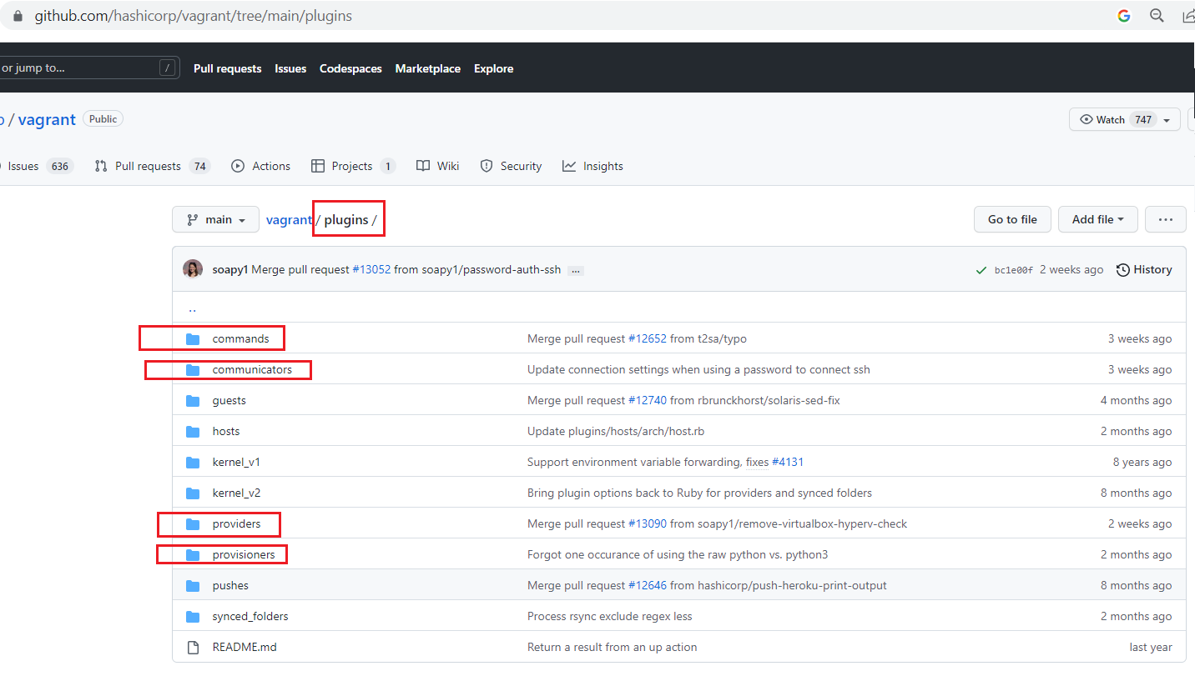

**Find plugins**

In package manager of ruby

<https://rubygems.org/?locale=fr>

$ **vagrant plugin -h**

Usage: vagrant plugin <command> [<args>]

Available subcommands:

expunge

install

license

list

repair

uninstall

update

For help on any individual command run `vagrant plugin COMMAND -h`

--[no-]color Enable or disable color output

--machine-readable Enable machine readable output

-v, --version Display Vagrant version

--debug Enable debug output

--timestamp Enable timestamps on log output

--debug-timestamp Enable debug output with timestamps

--no-tty Enable non-interactive output

**Lab-6**

Use this plugin vagrant-hostsupdater for this lab

<https://github.com/agiledivider/vagrant-hostsupdater>

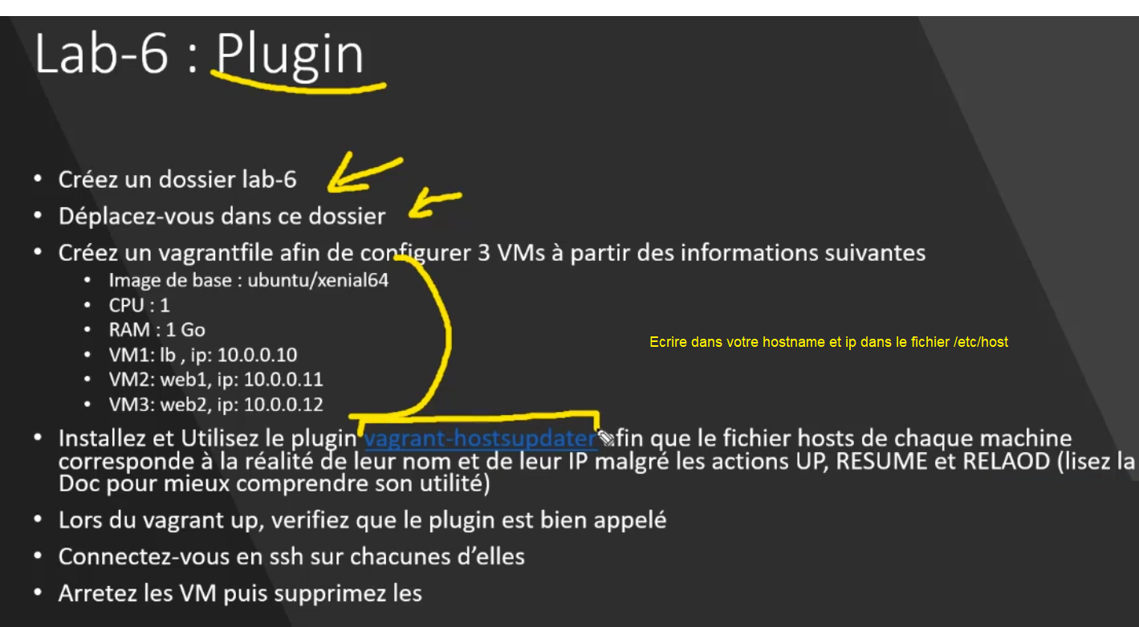

$ **mkdir lab-6**

$ **cd .\lab-6**

$ **vagrant init -m**

A `Vagrantfile` has been placed in this directory. You are now

ready to `vagrant up` your first virtual environment! Please read

the comments in the Vagrantfile as well as documentation on

`vagrantup.com` for more information on using Vagrant.

Uninstall plugin

$ **vagrant plugin uninstall vagrant-hostsupdater**

Installing the 'vagrant-hostsupdater' plugin. This can take a few minutes...

Fetching vagrant-hostsupdater-1.2.4.gem

Installed the plugin 'vagrant-hostsupdater (1.2.4)'!

Edit Vagranfile

RAM = 1024

CPU = 1

Vagrant.configure("2") do |config|

  # Configure load balancer machine

  config.vm.define "lb" do |lb|

    lb.vm.box = "ubuntu/xenial64"

    # using plugin vagrant-hostsupdater to get the hostname and ip and change the file /etc/host

    lb.vm.hostname = "lb"

    lb.vm.network "private_network" , ip: "10.0.0.10"

  end

  config.vm.provider "virtualbox" do |v|

    v.memory = RAM

    v.cpus = CPU

  end

  # Configure first web machine

  config.vm.define "web1" do |web1|

    web1.vm.box = "ubuntu/xenial64"

    # using plugin vagrant-hostsupdater to get the hostname and ip and change the file /etc/host

    web1.vm.hostname = "web1"

    web1.vm.network "private_network" , ip: "10.0.0.11"

  end

  config.vm.provider "virtualbox" do |v|

    v.memory = RAM

    v.cpus = CPU

  end

  # Configure first web machine

  config.vm.define "web2" do |web2|

    web2.vm.box = "ubuntu/xenial64"

    # using plugin vagrant-hostsupdater to get the hostname and ip and change the file /etc/host

    web2.vm.hostname = "lb"

    web2.vm.network "private_network" , ip: "10.0.0.12"

  end

  config.vm.provider "virtualbox" do |v|

    v.memory = RAM

    v.cpus = CPU

  end

end

$ **vagrant validate**

Vagrantfile validated successfully.

$ **vagrant up**

Bringing machine 'lb' up with 'virtualbox' provider...

Bringing machine 'web1' up with 'virtualbox' provider...

Bringing machine 'web2' up with 'virtualbox' provider...

==> lb: Importing base box 'ubuntu/xenial64'...

==> lb: Matching MAC address for NAT networking...

==> lb: Checking if box 'ubuntu/xenial64' version '20211001.0.0' is up to date...

==> lb: Setting the name of the VM: lab-6_lb_1678221041825_53913

==> lb: Clearing any previously set network interfaces...

==> lb: Preparing network interfaces based on configuration...

lb: Adapter 1: nat

lb: Adapter 2: hostonly

==> lb: Forwarding ports...

lb: 22 (guest) => 2222 (host) (adapter 1)

==> lb: Running 'pre-boot' VM customizations...

==> lb: Booting VM...

==> lb: Waiting for machine to boot. This may take a few minutes...

lb: SSH address: 127.0.0.1:2222

lb: SSH username: vagrant

lb: SSH auth method: private key

lb: Warning: Connection reset. Retrying...

lb:

lb: Vagrant insecure key detected. Vagrant will automatically replace

lb: this with a newly generated keypair for better security.

lb:

lb: Inserting generated public key within guest...

lb: Removing insecure key from the guest if it's present...

lb: Key inserted! Disconnecting and reconnecting using new SSH key...

==> lb: Machine booted and ready!

==> lb: Checking for guest additions in VM...

lb: The guest additions on this VM do not match the installed version of

lb: VirtualBox! In most cases this is fine, but in rare cases it can

lb: prevent things such as shared folders from working properly. If you see

lb: shared folder errors, please make sure the guest additions within the

lb: virtual machine match the version of VirtualBox you have installed on

lb: your host and reload your VM.

lb:

lb: Guest Additions Version: 5.1.38

lb: VirtualBox Version: 7.0

==> lb: [vagrant-hostsupdater] Checking for host entries

==> lb: [vagrant-hostsupdater] Writing the following entries to (C:/WINDOWS/system32/drivers/etc/hosts)

==> lb: [vagrant-hostsupdater] 10.0.0.10 lb # VAGRANT: c84c41d1f38f2211ceb376b42f22e221 (lb) / a7857546-36cc-430e-a776-6f8689f15d70

==> lb: Setting hostname...

==> lb: Configuring and enabling network interfaces...

==> lb: Mounting shared folders...

lb: /vagrant => C:/Users/yzaghir/Downloads/vagrant_information/labs/lab-6

==> web1: Importing base box 'ubuntu/xenial64'...

==> web1: Matching MAC address for NAT networking...

==> web1: Checking if box 'ubuntu/xenial64' version '20211001.0.0' is up to date...

==> web1: Setting the name of the VM: lab-6_web1_1678221161318_37722

==> web1: Fixed port collision for 22 => 2222. Now on port 2200.

==> web1: Clearing any previously set network interfaces...

==> web1: Preparing network interfaces based on configuration...

web1: Adapter 1: nat

web1: Adapter 2: hostonly

==> web1: Forwarding ports...

web1: 22 (guest) => 2200 (host) (adapter 1)

==> web1: Running 'pre-boot' VM customizations...

==> web1: Booting VM...

==> web1: Waiting for machine to boot. This may take a few minutes...

web1: SSH address: 127.0.0.1:2200

web1: SSH username: vagrant

web1: SSH auth method: private key

web1:

web1: Vagrant insecure key detected. Vagrant will automatically replace

web1: this with a newly generated keypair for better security.

web1:

web1: Inserting generated public key within guest...

web1: Removing insecure key from the guest if it's present...

web1: Key inserted! Disconnecting and reconnecting using new SSH key...

==> web1: Machine booted and ready!

==> web1: Checking for guest additions in VM...

web1: The guest additions on this VM do not match the installed version of

web1: VirtualBox! In most cases this is fine, but in rare cases it can

web1: prevent things such as shared folders from working properly. If you see

web1: shared folder errors, please make sure the guest additions within the

web1: virtual machine match the version of VirtualBox you have installed on

web1: your host and reload your VM.

web1:

web1: Guest Additions Version: 5.1.38

web1: VirtualBox Version: 7.0

==> web1: [vagrant-hostsupdater] Checking for host entries

==> web1: [vagrant-hostsupdater] Writing the following entries to (C:/WINDOWS/system32/drivers/etc/hosts)

==> web1: [vagrant-hostsupdater] 10.0.0.11 web1 # VAGRANT: 5de972bdf1d533ead640979df3ac3713 (web1) / 3ce3dd2c-9b00-4c80-82b8-329d7502208c

==> web1: Setting hostname...

==> web1: Configuring and enabling network interfaces...

==> web1: Mounting shared folders...

web1: /vagrant => C:/Users/yzaghir/Downloads/vagrant_information/labs/lab-6

==> web2: Importing base box 'ubuntu/xenial64'...

==> web2: Matching MAC address for NAT networking...

==> web2: Checking if box 'ubuntu/xenial64' version '20211001.0.0' is up to date...

==> web2: Setting the name of the VM: lab-6_web2_1678221263098_1580

==> web2: Fixed port collision for 22 => 2222. Now on port 2201.

==> web2: Clearing any previously set network interfaces...

==> web2: Preparing network interfaces based on configuration...

web2: Adapter 1: nat

web2: Adapter 2: hostonly

==> web2: Forwarding ports...

web2: 22 (guest) => 2201 (host) (adapter 1)

==> web2: Running 'pre-boot' VM customizations...

==> web2: Booting VM...

==> web2: Waiting for machine to boot. This may take a few minutes...

web2: SSH address: 127.0.0.1:2201

web2: SSH username: vagrant

web2: SSH auth method: private key

web2: Warning: Connection reset. Retrying...

web2:

web2: Vagrant insecure key detected. Vagrant will automatically replace

web2: this with a newly generated keypair for better security.

web2:

web2: Inserting generated public key within guest...

web2: Removing insecure key from the guest if it's present...

web2: Key inserted! Disconnecting and reconnecting using new SSH key...

==> web2: Machine booted and ready!

==> web2: Checking for guest additions in VM...

web2: The guest additions on this VM do not match the installed version of

web2: VirtualBox! In most cases this is fine, but in rare cases it can

web2: prevent things such as shared folders from working properly. If you see

web2: shared folder errors, please make sure the guest additions within the

web2: virtual machine match the version of VirtualBox you have installed on

web2: your host and reload your VM.

web2:

web2: Guest Additions Version: 5.1.38

web2: VirtualBox Version: 7.0

==> web2: [vagrant-hostsupdater] Checking for host entries

==> web2: [vagrant-hostsupdater] Writing the following entries to (C:/WINDOWS/system32/drivers/etc/hosts)

==> web2: [vagrant-hostsupdater] 10.0.0.12 lb # VAGRANT: 17c24eb5ff127cb4021e014b6b6df2d2 (web2) / d5fea4dd-61d9-41be-9ca8-c670f4564cda

==> web2: Setting hostname...

==> web2: Configuring and enabling network interfaces...

==> web2: Mounting shared folders...

web2: /vagrant => C:/Users/yzaghir/Downloads/vagrant_information/labs/lab-6

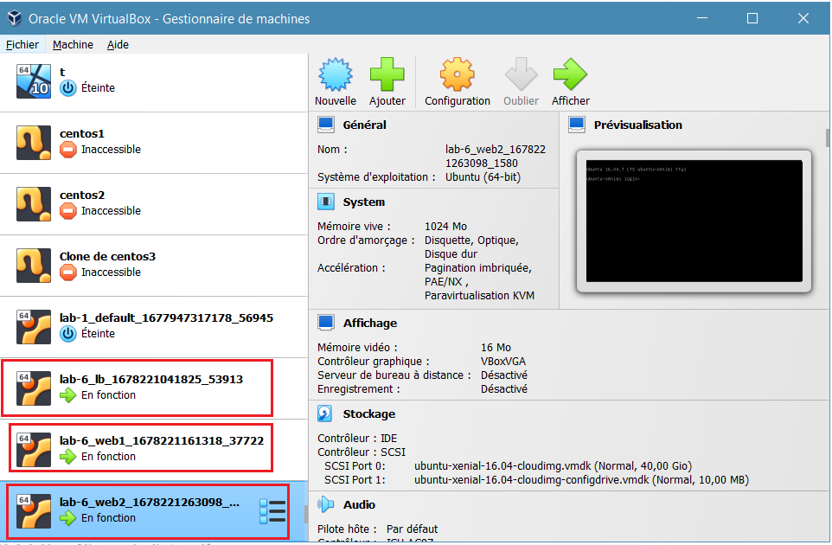

$ **vagrant ssh lb**

vagrant@lb:~$

$ **logout**

$ **vagrant destroy -f**

**File**

**Montage des fichiers dans les vms avec l’option synced_older**

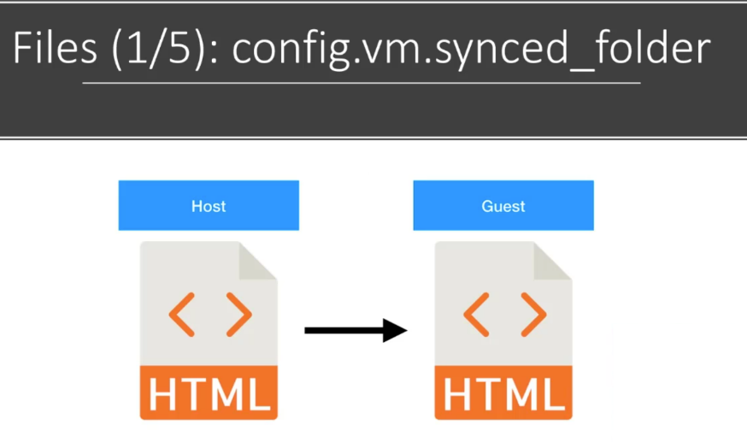

**Basic Syncing**

<https://developer.hashicorp.com/vagrant/docs/synced-folders/basic_usage>

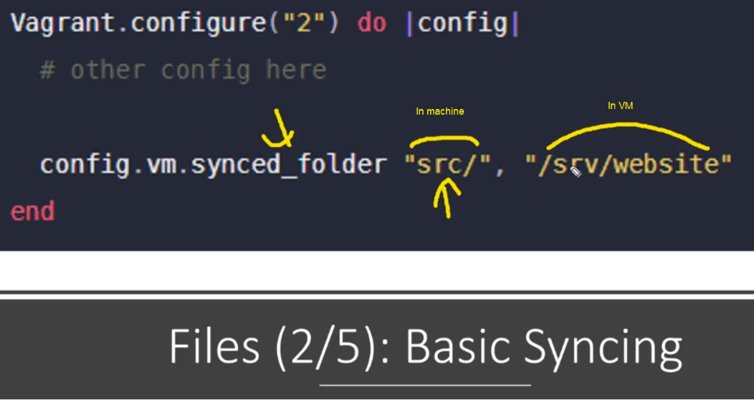

**NFS**

You should to install a NFS server

<https://developer.hashicorp.com/vagrant/docs/synced-folders/nfs>

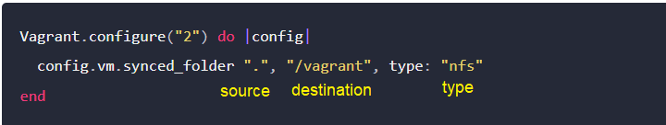

**Rsync**

Rsync commande pour la syncronisation des dossiers

<https://developer.hashicorp.com/vagrant/docs/synced-folders/rsync>

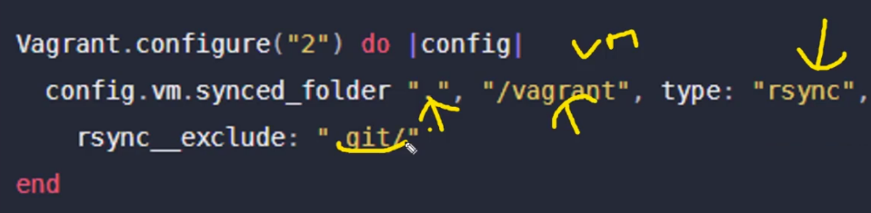

**Update fine and folder**

Copie seulement les fichers ce n’est pas un montage qui peut les modifier

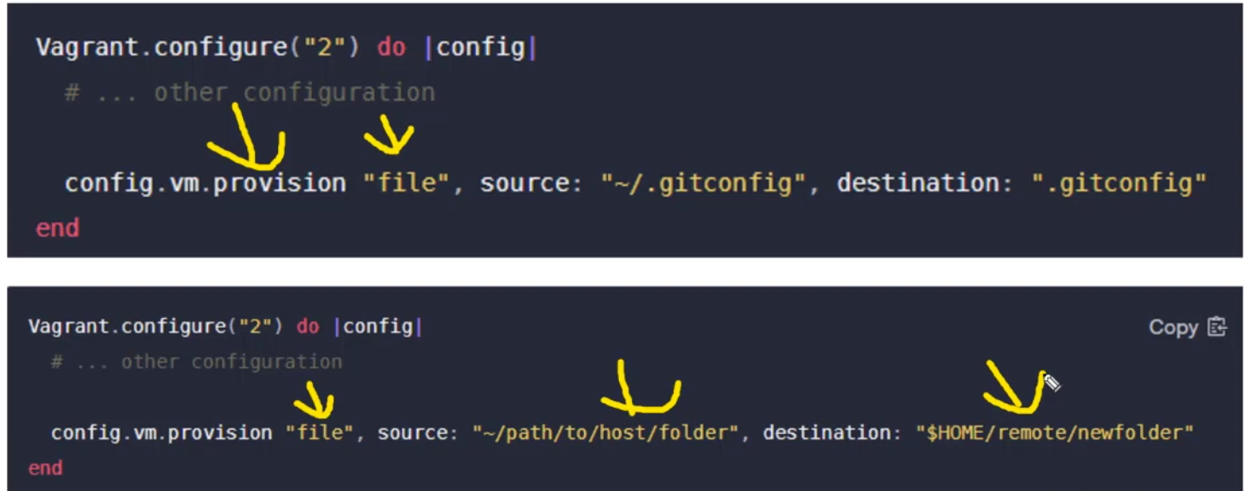

**Lab-7**

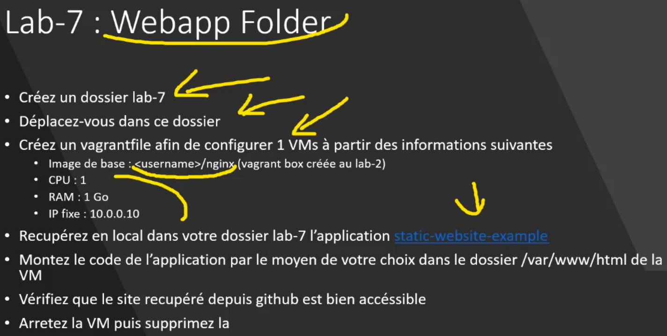

**$ mkdir lab-7**

$ **cd lab-7**

$ **vagrant init -m**

$ **git clone https://github.com/diranetafen/static-website-example.git**

Edit Vagranfile

RAM = 1024

CPU = 1

IP = "10.0.0.10"

Vagrant.configure("2") do |config|

  config.vm.box = "dirane/nginx"

  config.vm.box_version = "1.0"

  config.vm.hostname = "nginx"

  config.vm.network "private_network", ip: IP

#  old version of nginx

  #config.vm.synced_folder "static-website-example", "/usr/share/nginx/html/"

  config.vm.synced_folder "static-website-example", "/var/www/html/"

  config.vm.provider "virtualbox" do |v|

    v.memory = RAM

    v.cpus = CPU

  end

end

$ **vagrant validate**

Vagrantfile validated successfully.

$ **vagrant up**

Bringing machine 'default' up with 'virtualbox' provider...

==> default: Box 'dirane/nginx' could not be found. Attempting to find and install...

default: Box Provider: virtualbox

default: Box Version: 1.0

==> default: Loading metadata for box 'dirane/nginx'

default: URL: https://vagrantcloud.com/dirane/nginx

==> default: Adding box 'dirane/nginx' (v1.0) for provider: virtualbox

default: Downloading: https://vagrantcloud.com/dirane/boxes/nginx/versions/1.0/providers/virtualbox.box

default:

==> default: Successfully added box 'dirane/nginx' (v1.0) for 'virtualbox'!

==> default: Importing base box 'dirane/nginx'...

==> default: Matching MAC address for NAT networking...

==> default: Checking if box 'dirane/nginx' version '1.0' is up to date...

==> default: Setting the name of the VM: lab-7_default_1678224536060_94333

==> default: Clearing any previously set network interfaces...

==> default: Preparing network interfaces based on configuration...

default: Adapter 1: nat

default: Adapter 2: hostonly

==> default: Forwarding ports...

default: 22 (guest) => 2222 (host) (adapter 1)

==> default: Running 'pre-boot' VM customizations...

==> default: Booting VM...

==> default: Waiting for machine to boot. This may take a few minutes...

default: SSH address: 127.0.0.1:2222

default: SSH username: vagrant

default: SSH auth method: private key

==> default: Machine booted and ready!

==> default: Checking for guest additions in VM...

default: The guest additions on this VM do not match the installed version of

default: VirtualBox! In most cases this is fine, but in rare cases it can

default: prevent things such as shared folders from working properly. If you see

default: shared folder errors, please make sure the guest additions within the

default: virtual machine match the version of VirtualBox you have installed on

default: your host and reload your VM.

default:

default: Guest Additions Version: 4.3.40

default: VirtualBox Version: 7.0

==> default: [vagrant-hostsupdater] Checking for host entries

==> default: [vagrant-hostsupdater] Writing the following entries to (C:/WINDOWS/system32/drivers/etc/hosts)

==> default: [vagrant-hostsupdater] 10.0.0.10 nginx # VAGRANT: 66c6666dd909c5bd0ae72d1fcaa1996e (default) / ed9a46b1-043e-4405-991a-a6f5aa0e85e8

==> default: Setting hostname...

==> default: Configuring and enabling network interfaces...

==> default: Mounting shared folders...

default: /vagrant => C:/Users/yzaghir/Downloads/vagrant_information/labs/lab-7

default: /var/www/html => C:/Users/yzaghir/Downloads/vagrant_information/labs/lab-7/static-website-example

$ **vagrant ssh**

$ **sudo service nginx status**

* nginx is running

$ **ls /var/www/html/**

assets error images index.html LICENSE.MD README.MD

$ ip a

1: lo: <LOOPBACK,UP,LOWER_UP> mtu 65536 qdisc noqueue state UNKNOWN group default

link/loopback 00:00:00:00:00:00 brd 00:00:00:00:00:00

inet 127.0.0.1/8 scope host lo

valid_lft forever preferred_lft forever

inet6 ::1/128 scope host

valid_lft forever preferred_lft forever

2: eth0: <BROADCAST,MULTICAST,UP,LOWER_UP> mtu 1500 qdisc pfifo_fast state UP group default qlen 1000

link/ether 08:00:27:5f:bb:e6 brd ff:ff:ff:ff:ff:ff

inet 10.0.2.15/24 brd 10.0.2.255 scope global eth0 default ip

valid_lft forever preferred_lft forever

inet6 fe80::a00:27ff:fe5f:bbe6/64 scope link

valid_lft forever preferred_lft forever

3: eth1: <BROADCAST,MULTICAST,UP,LOWER_UP> mtu 1500 qdisc pfifo_fast state UP group default qlen 1000

link/ether 08:00:27:45:b8:8a brd ff:ff:ff:ff:ff:ff

inet 10.0.0.10/24 brd 10.0.0.255 scope global eth1 ip address

valid_lft forever preferred_lft forever

inet6 fe80::a00:27ff:fe45:b88a/64 scope link

valid_lft forever preferred_lft forever

**http://10.0.0.10**

On peut faire des modifications directement dans le fichier sources qui est monter dans la vm

Partager les fichier de logs

$ **logout**

$**vagrant destroy -f**

**Shell Provisioning**

Le provisionner intervient après la phase de la création (4)

Le provider c’est avant (Virtualbox 2 )

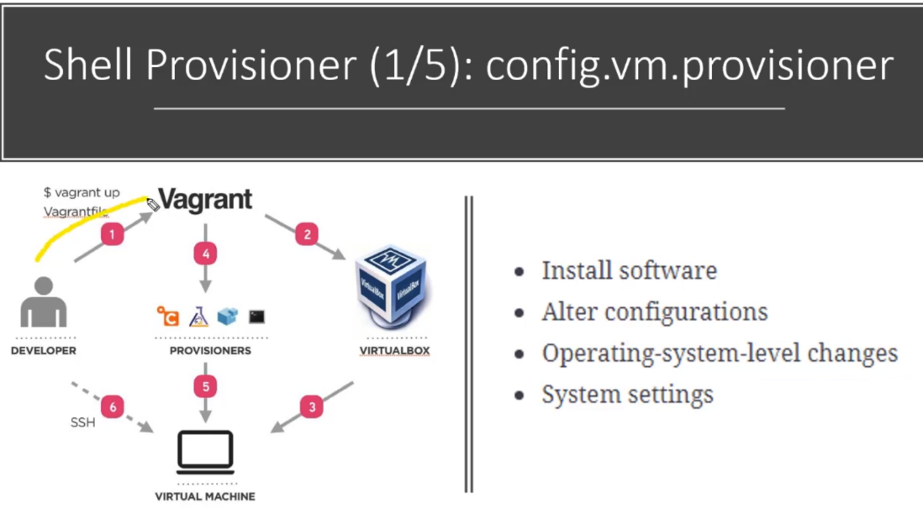

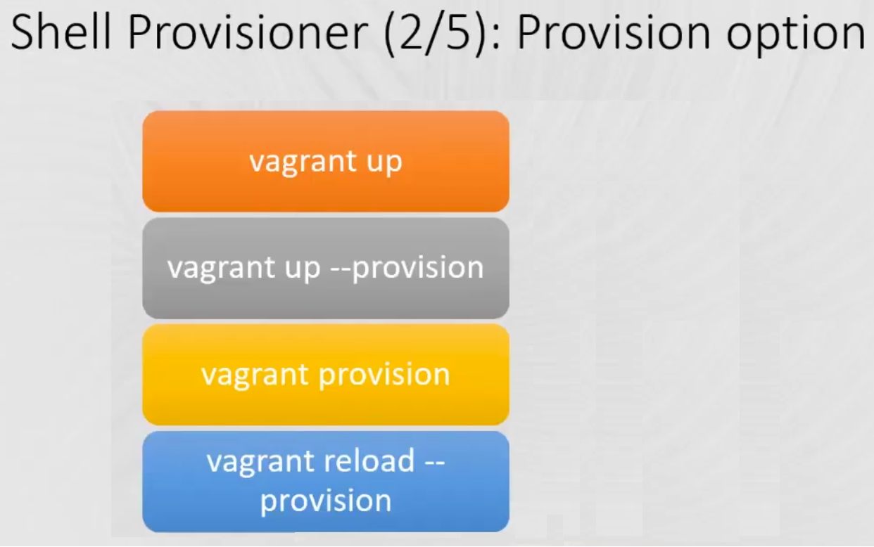

**Shell provisioner : Inline Shell**

<https://developer.hashicorp.com/vagrant/docs/provisioning/shell>

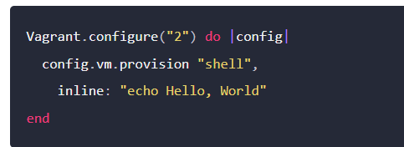

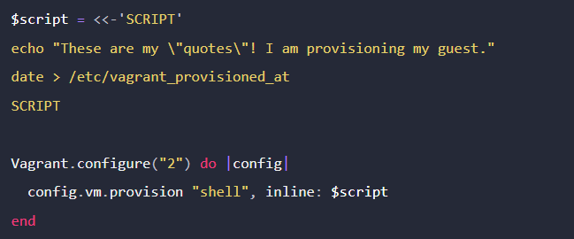

**Shell provisioner : External Shell**

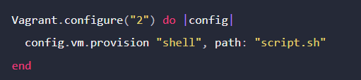

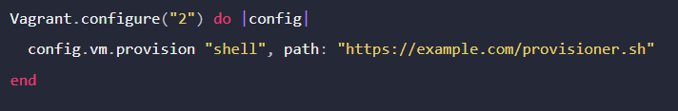

**Shell provisioner : Arguments**

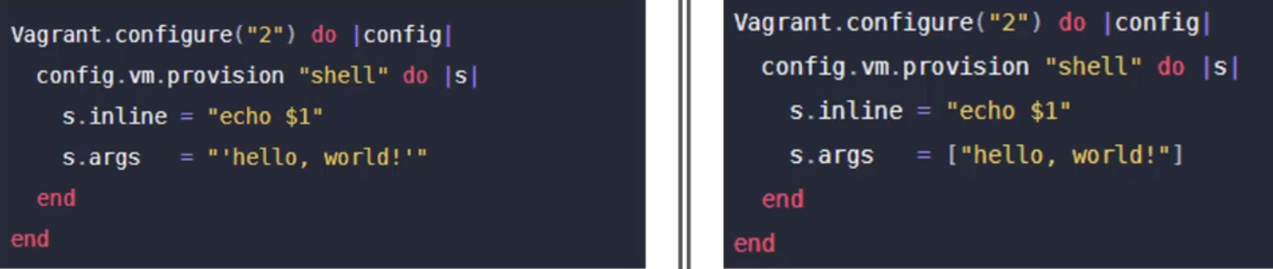

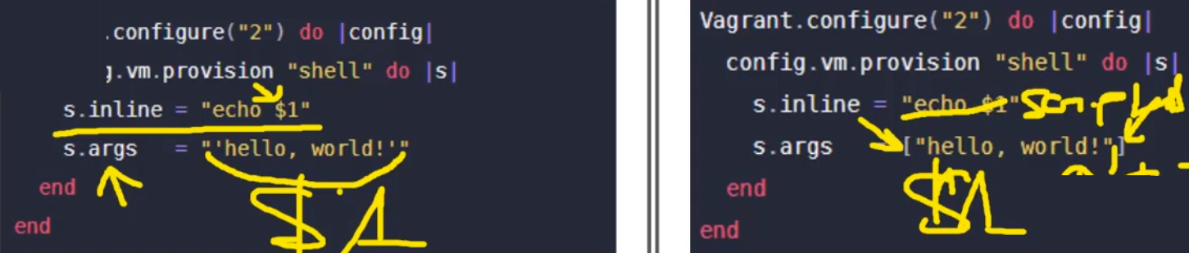

**Lab-8**

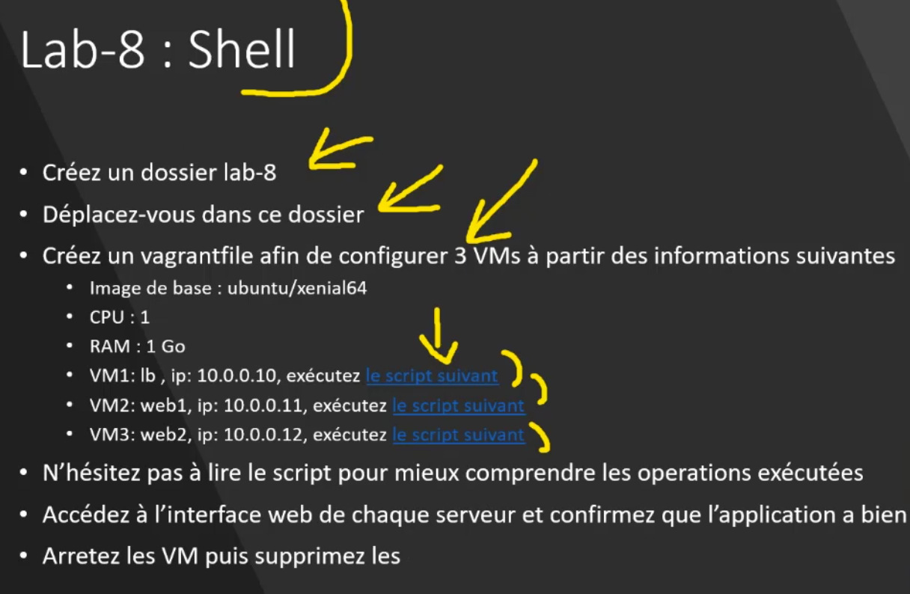

$ **cd ..**

$ **mkdir lab-8**

$ **cd lab-8**

$ **vagrant init -m**

Edit Vagrantfile

RAM = 1024

CPU = 1

Vagrant.configure("2") do |config|

  # Configure load balancer machine

  config.vm.define "lb" do |lb|

    lb.vm.box = "ubuntu/xenial64"

    # using plugin vagrant-hostsupdater

    lb.vm.hostname = "lb"

    lb.vm.network "private_network" , ip: "10.0.0.10"

    lb.vm.provision :shell do |shell|

      shell.path = "https://raw.githubusercontent.com/PacktPublishing/Hands-On-DevOps-with-Vagrant/master/Chapter07/lb.sh"

    end

  end

  config.vm.provider "virtualbox" do |v|

    v.memory = RAM

    v.cpus = CPU

  end

  # Configure first web machine

  config.vm.define "web1" do |web1|

    web1.vm.box = "ubuntu/xenial64"

    # using plugin vagrant-hostsupdater

    web1.vm.hostname = "web1"

    web1.vm.network "private_network" , ip: "10.0.0.11"

    web1.vm.provision :shell do |shell|

      shell.path = "https://raw.githubusercontent.com/PacktPublishing/Hands-On-DevOps-with-Vagrant/master/Chapter07/web.sh"

      shell.args = "1"

    end

  end

  config.vm.provider "virtualbox" do |v|

    v.memory = RAM

    v.cpus = CPU

  end

  # Configure first web machine

  config.vm.define "web2" do |web2|

    web2.vm.box = "ubuntu/xenial64"

    # using plugin vagrant-hostsupdater

    web2.vm.hostname = "web2"

    web2.vm.network "private_network" , ip: "10.0.0.12"

    web2.vm.provision :shell do |shell|

      shell.path = "https://raw.githubusercontent.com/PacktPublishing/Hands-On-DevOps-with-Vagrant/master/Chapter07/web.sh"

      shell.args = "2"

    end

  end

  config.vm.provider "virtualbox" do |v|

    v.memory = RAM

    v.cpus = CPU

  end

end

$ **vagrant validate**

Vagrantfile validated successfully.

$ **vagrant up**

λ vagrant up

Bringing machine 'lb' up with 'virtualbox' provider...

Bringing machine 'web1' up with 'virtualbox' provider...

Bringing machine 'web2' up with 'virtualbox' provider...

==> lb: Importing base box 'ubuntu/xenial64'...

==> lb: Matching MAC address for NAT networking...

==> lb: Checking if box 'ubuntu/xenial64' version '20211001.0.0' is up to date...

==> lb: Setting the name of the VM: lab-8_lb_1678228292110_95062

==> lb: Clearing any previously set network interfaces...

==> lb: Preparing network interfaces based on configuration...

lb: Adapter 1: nat

lb: Adapter 2: hostonly

==> lb: Forwarding ports...

lb: 22 (guest) => 2222 (host) (adapter 1)

==> lb: Running 'pre-boot' VM customizations...

==> lb: Booting VM...

==> lb: Waiting for machine to boot. This may take a few minutes...

lb: SSH address: 127.0.0.1:2222

lb: SSH username: vagrant

lb: SSH auth method: private key

lb:

lb: Vagrant insecure key detected. Vagrant will automatically replace

lb: this with a newly generated keypair for better security.

lb:

lb: Inserting generated public key within guest...

lb: Removing insecure key from the guest if it's present...

lb: Key inserted! Disconnecting and reconnecting using new SSH key...

==> lb: Machine booted and ready!

==> lb: Checking for guest additions in VM...

lb: The guest additions on this VM do not match the installed version of

lb: VirtualBox! In most cases this is fine, but in rare cases it can

lb: prevent things such as shared folders from working properly. If you see

lb: shared folder errors, please make sure the guest additions within the

lb: virtual machine match the version of VirtualBox you have installed on

lb: your host and reload your VM.

lb:

lb: Guest Additions Version: 5.1.38

lb: VirtualBox Version: 7.0

==> lb: [vagrant-hostsupdater] Checking for host entries

==> lb: [vagrant-hostsupdater] Writing the following entries to (C:/WINDOWS/system32/drivers/etc/hosts)

==> lb: [vagrant-hostsupdater] 10.0.0.10 lb # VAGRANT: 42cca3b243574eae1e175b3b7a8e58e9 (lb) / 2fd0f8ff-9a4d-483f-979a-7b1f39c6693a

==> lb: Setting hostname...

==> lb: Configuring and enabling network interfaces...

==> lb: Mounting shared folders...

lb: /vagrant => C:/Users/yzaghir/Downloads/vagrant_information/labs/lab-8

==> lb: Running provisioner: shell...

lb: Running: C:/Users/yzaghir/AppData/Local/Temp/vagrant-shell20230307-25560-anm36u.sh

lb: Starting Provision: lb1

Lb = loadbalancer

